

TOPIC:

E- REPORTING FUNCTIONALITY IN MICROSOFT DYNAMICS 365

**Organizer: Dynamics stars LLC**

**Presenter: Dharmit Jain**



customers)

you can distribute formats to partners and customers through Microsoft Dynamics Lifecycle Services (LCS).

◆

ER currently supports the TEXT, XML, Microsoft Word /Excel documents, and OPENXML worksheet formats

◆

process of creating and adjusting custom formats for electronic documents is quick and easy.

You can manage multiple formats during their lifecycle. In ER, as the focus is to configure formats instead of coding, so the

◆

You can electronically exchange these documents with government bodies, banks, and business partners (e.g.. vendors and

◆

The implementation is vast: you can adopt new regulatory requirements and generate business documents accordingly.

◆

countries/regions)

You can use this tool for internal reporting, data loads, as well as external reporting (e.g. legal requirements of various

◆

configure ER.

**functional consultants** or **business users** who have good knowledge of the Dynamics 365 data structure can easily

it to configure formats for both **incoming and outgoing electronic documents**. No coding or queries are required, meaning

**Generic Electronic Reporting (GER)** or **Electronic Reporting (ER)** is a new configurable tool in Dynamics 365. We can use

◆

What is Electronic Reporting?



◆

services)

1.Operation Resources 2.LCS(life cycle services) 3.RCS (Regulatory configuration

A configuration provider can have 3 types of repositories

reporting configurations.

repository. A repository is a storage location that can be used as a source for Electronic

A configuration can be directly imported from a file or it can be imported from a

◆

The configuration provider Microsoft.com is present by default.

owner of the ERC and is the party authorized to make changes to the configuration.

At the basis of each ERC is a configuration provider. The configuration provider is the

◆

What is reporting configuration

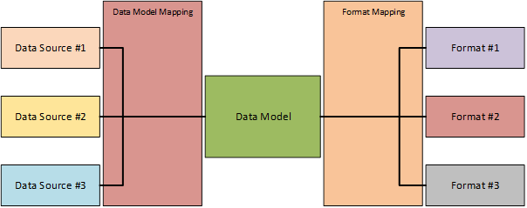

Electronic reporting Configuration

structure

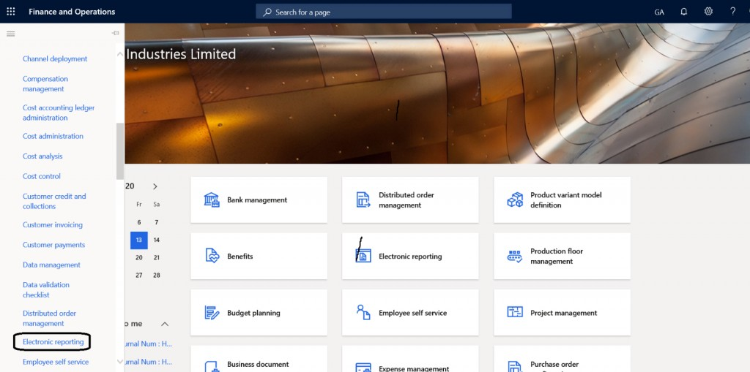

How to set Report configuration

provider

◆

Go to workspace >Electronic reporting

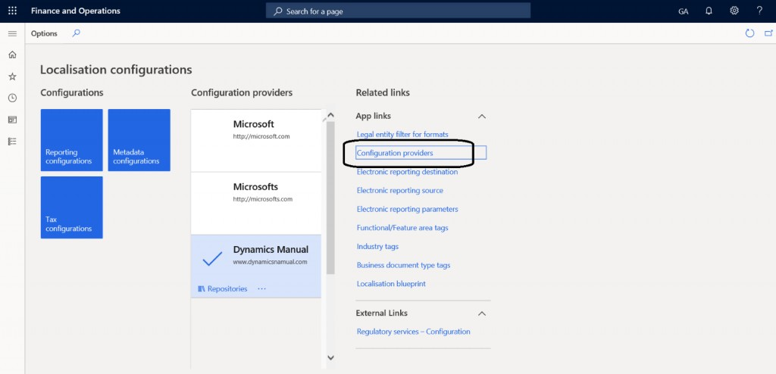

◆

Go to Configuration button related to the link.

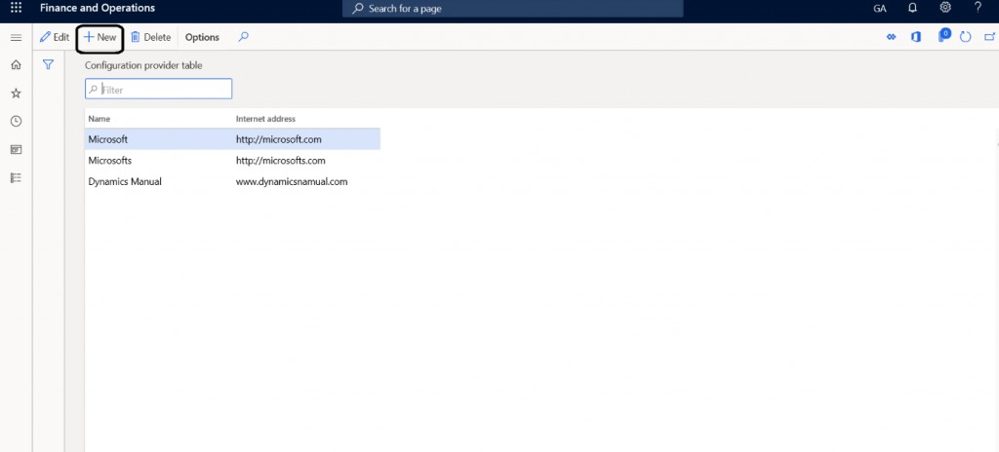

◆

Click on the new button to create configuration provider

◆

Give the name and respective Internet address to do the configuration.

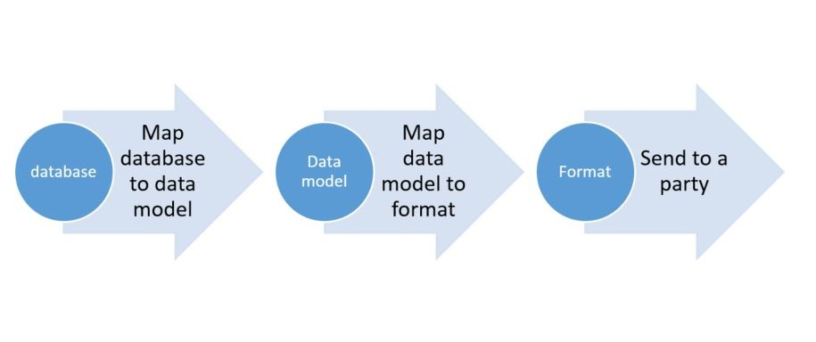

◆

**Format:** Format is the output of the report

Dynamics 365

**Data mapping:** Data mapping is for the mapping of data sources in

◆

designer.

**Data Model:** Provides the structure through which data is available to the

◆

There are there types of components of electronic reporting

Components of Electronic reporting



model already is provided by Microsoft in LCS. If a configuration is provided by Microsoft

changed.

updated model from Microsoft, you only have to worry about the fields you have

do not have to start from scratch and if the data source is updated, you can use the

This Data Model is then called a derived configuration. The main advantage is that you

◆

the Microsoft Data model.

and this is not fitting for your needs, you can create a custom configuration based on

Before creating a custom data model, it is recommended to check if a similar data

◆

list.

Boolean, and so on. If needed a data model can also include other records or a record

or fields. Each data item can be recognized as a string, integer, real, date, enumeration,

Data can be related to any business domain area. The data model includes data items

it is a container of a record. It should have enough details to fulfill the reporting need.

◆

source for format configurations to have the output elements bound to.

structure for the data sources to be bound to via a model mapping and providing the

A data model is the key element in an Electronic Reporting Configuration, providing the

◆

what is data model?

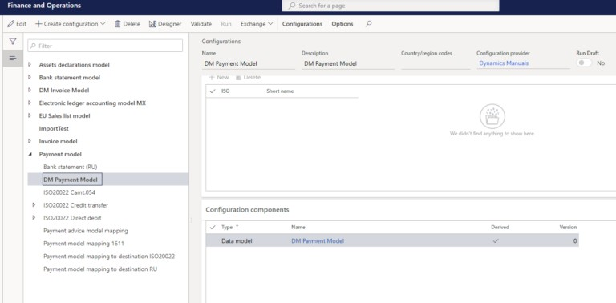

in this post. Enter a name and description and click on create.

here, you first have to create your own configuration provider as described

model> and click Create. If you see the configuration provider Microsoft

from and click on create configuration. Select Derive from Name: <data

To create a Derived data model, select the data model you want to derive

◆

Derived Data model

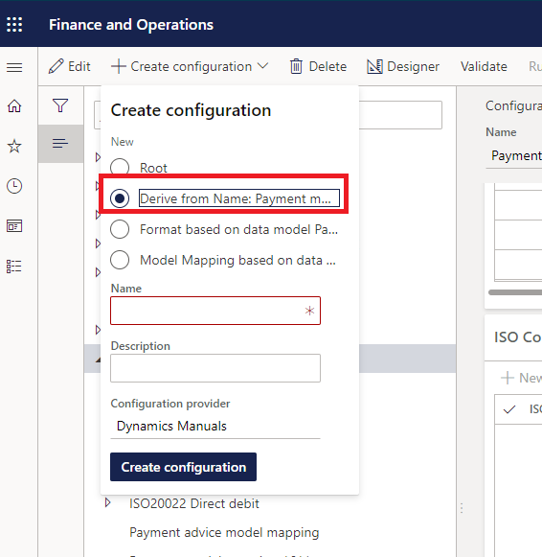

Derive data model

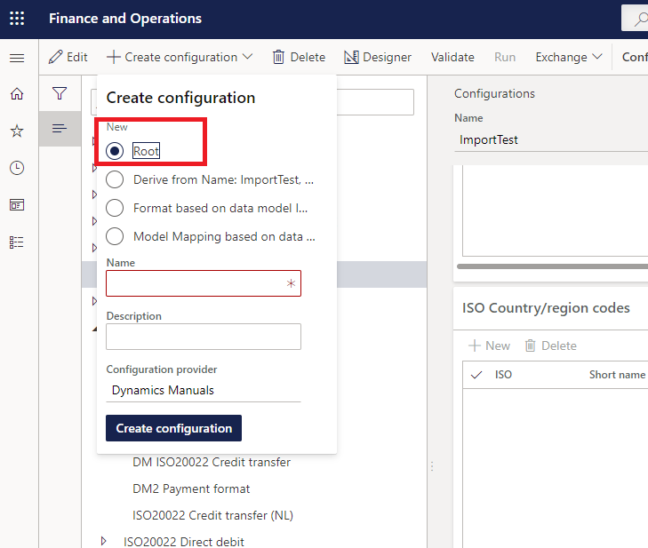

◆

further slide.

requirement which I will explain in

the data model according the

After that we can add our field in

default, this can not be changed.

new root is a data model by

give in a name and description. A

configuration) and select Root and

you have selected any existing

configuration (it does not matter if

model. To do this click on create

you can create a brand-new data

Microsoft LCS or other sources,

data source suitable from the

Alternatively, if you do not see any

◆



importing data and To Model which is used for exporting data. The same goes for

mapping in the format mapping. The image below illustrates this.

designer and when importing data, the mapping is performed via the model

a format mapping, when exporting data, the mapping is performed directly in the

 A model mapping can have two directions, To Destination which is used for

◆

import).

in the data model. The mapping can be to a model (= export) or a destination (=

possible to separate the model mapping in its own ERC, but it is often combined

table, a data entity, a map or a view to the Data Model. Since update 1611 it is

the model mapping is the binding of the data source in D365FO, which can be a

◆

Data model Mapping

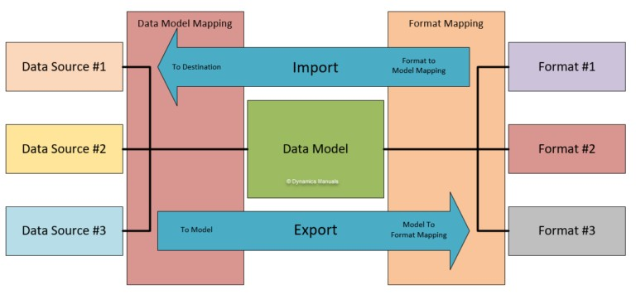

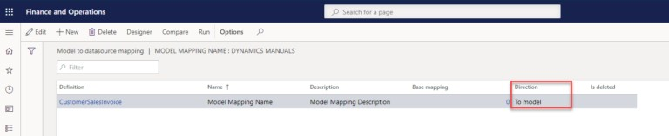

mapping for. Click on Designer and you will see that Electronic Reporting

defaulted in a To Model direction (export) for our model mapping.

and by this telling Electronic Reporting the direction we are creating the

creating the configuration. The second step is to create the actual mapping

We have now done the first step in creating a model mapping and that is

◆

configuration.

data model definition you want to use in the mapping and click create

mapping for and click Create configuration. Enter a name and select the

To create a model mapping select the data model you want to create the

◆

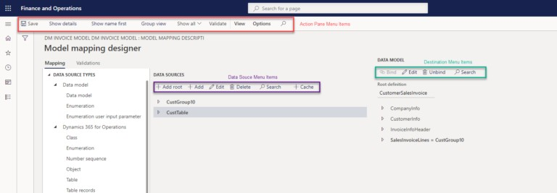

Model Mapping Designer Menu

Overview

In further slide I will explain how to mapped data model field with

the data source. Here you might get idea how it works.



requires a different approach in setup than a format for export. Another feature is

based upon the exported data, this can be very useful but complex in set up as well.

that you can write back information into Dynamics 365 for Finance and Operations

use differ slightly per file type you are configuring, configuring a format for import

input or output file. Because of this characteristic the configuration components and

The format mapping is the configuration component which determines the type of

◆

follow the order Data model, to Model Mapping, to Format Mapping.

the data model. Setting up a new Electronic Reporting configuration requires you to

 The format mapping is the binding of the format destination or source (the file) to

◆

Format mapping

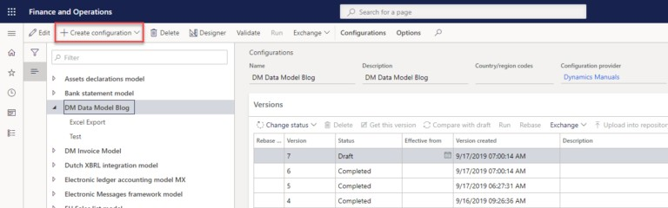

Create export Format mapping

◆

To create a new export format mapping select a data model you

want to create a format mapping in and click on <create

configuration>.

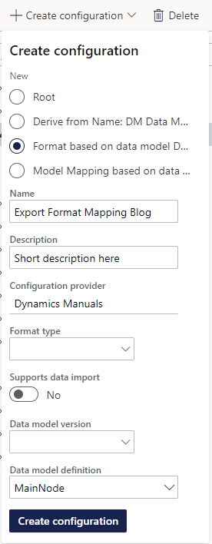

editor and leave Supports Import on No.

Reporting will fill in the latest version by default.

recommend keeping it empty as Electronic

The data model version is optional to fill in, but I

◆

limit the choices you have later in the format

import formats and selecting a format type will

Leave the format type empty, this is intended for

◆

the export format on.

select the Data model definition you are basing

fill in and for an export format you are required to

The description is optional but recommended to

◆

data model XYZ> and enter a name.

Then select the radio button <Format based on

◆

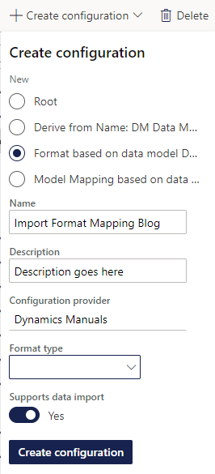

mapping. Because there can be multiple import format’s pointing at the

create configuration to create the import mapping.

configuration a little bit easier because of the cleaner drop downs. Click on

the available options in the mapping designer as well, making

format mapping to use for which file type. Besides this, the file type filters

same model mapping, this format type field tells Electronic Reporting which

as imports are not run from the format mapping but from the model

Although the file format type is not mandatory, it is recommended to fill in

◆

data import to yes and determine a file format type you will be importing.

enter a name and an optional description. Set the radio button for supports

Again, select the radio button <Format based on data model XYZ>, and

◆

Mapping click on <create configuration>.

The creation of an import format mapping is much like an Export Format

◆

Mapping

Creating an Import Format

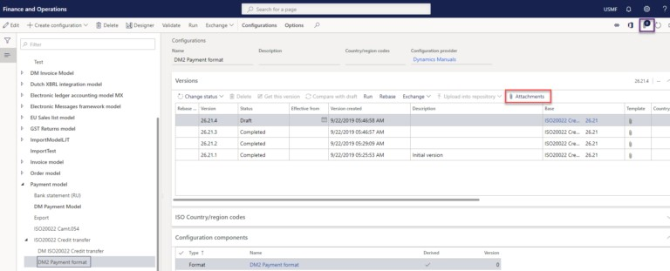

Reporting can’t create the file and requires a

model .I will explore it with the requirement.

How can we mapped format with the data

◆

format mapping configuration.

template file is added as an attachment to the

template file to which the data is mapped. This

not text-based (Excel, Word, PDF), Electronic

However, when exporting data to a file which is

◆

file and performing the mapping of the data.

Electronic Reporting can facilitate creating the

text-based file (JSON, XML, Other Text),

by this configuration. When exporting data to a

a file is created, and its contents are mapped

determines the file type. When exporting files,

format mapping is the configuration which

for importing data and exporting data. The

Electronic reporting supports different file types

◆

Attachments



So Firstly We Will Import Model And Add The Field In The Model Then This Field Will

Version Of These Should Be Same .

◆

Mapped With Data Source And After That We Will Proceed The Formatting Part.

◆

Related To This Field.

For Fulfillment Of This Requirement We Need To Find The Data Source And Model

◆

Suppose We Have A Requirement To Add A Cust Group Name In Sales Invoice Report.

◆

Now I Will Explain What I Discussed In The Previous Slides.

◆

Requirement

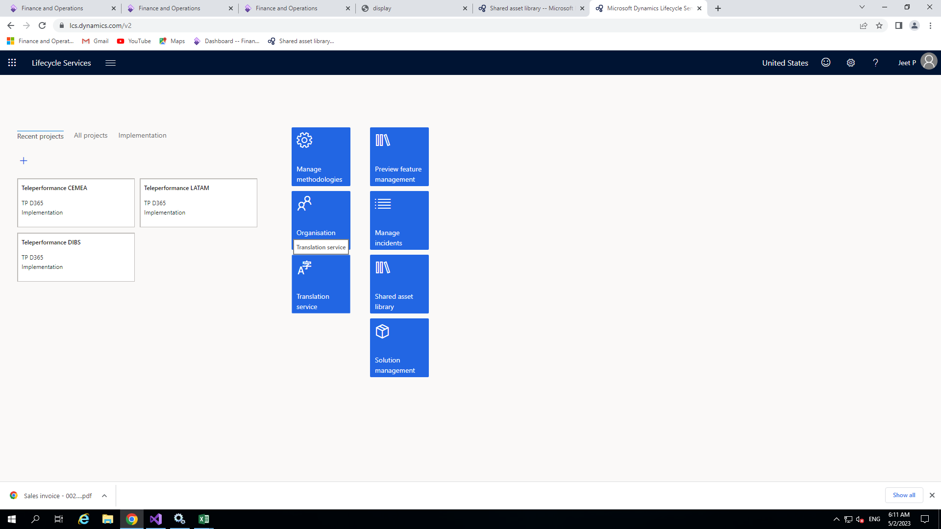

How to do it?

**Import Microsoft Model, Mapping and Format for ER**

◆

For importing Microsoft model, format and model mapping first of all go to

LCS by simply type lcs.dynamics.com in the address bar of the browser.

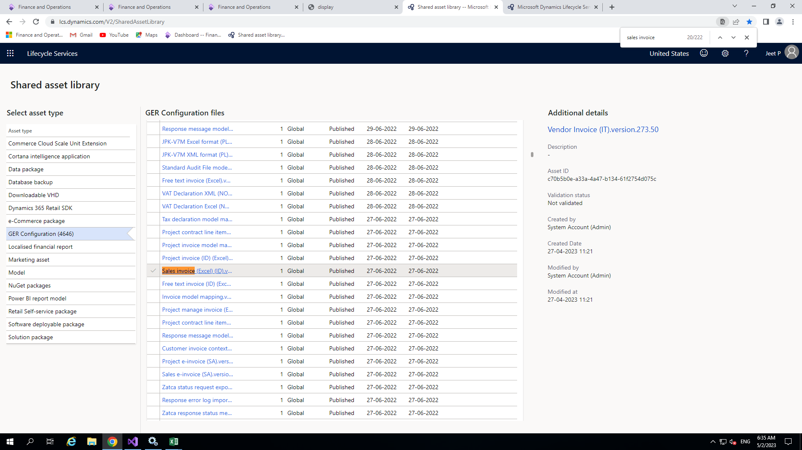

◆

After that go to shared asset library -> GER Configuration and search for

Invoice model , Invoice model mapping and sales invoice(Excel) template of

appropriate version. The version of all these should be same .

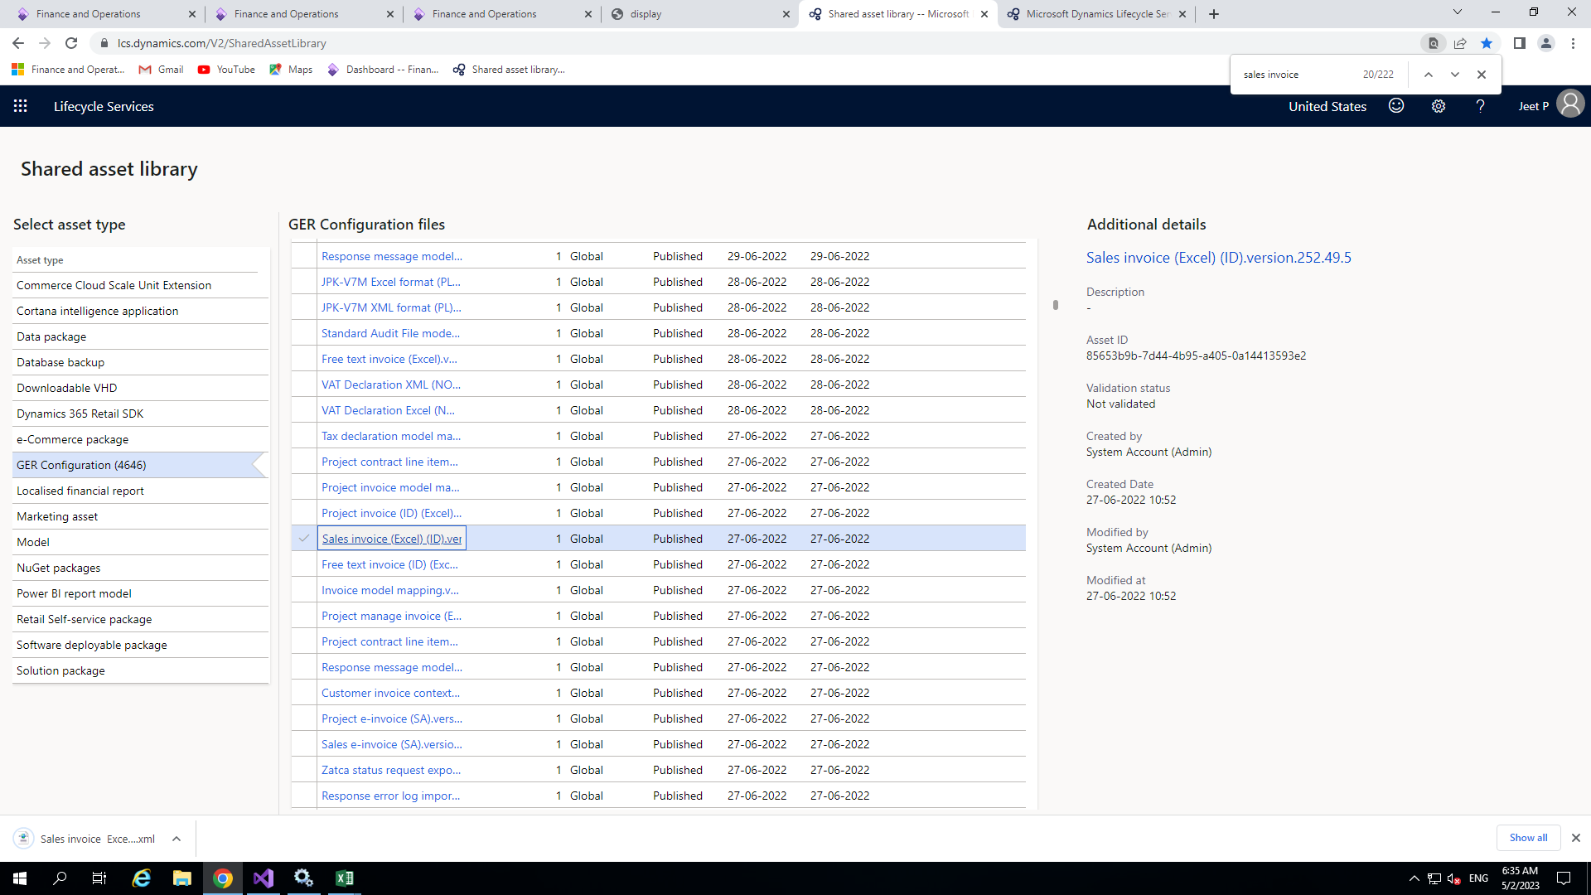

◆

Just simply click on these then the appropriate xml file will download.

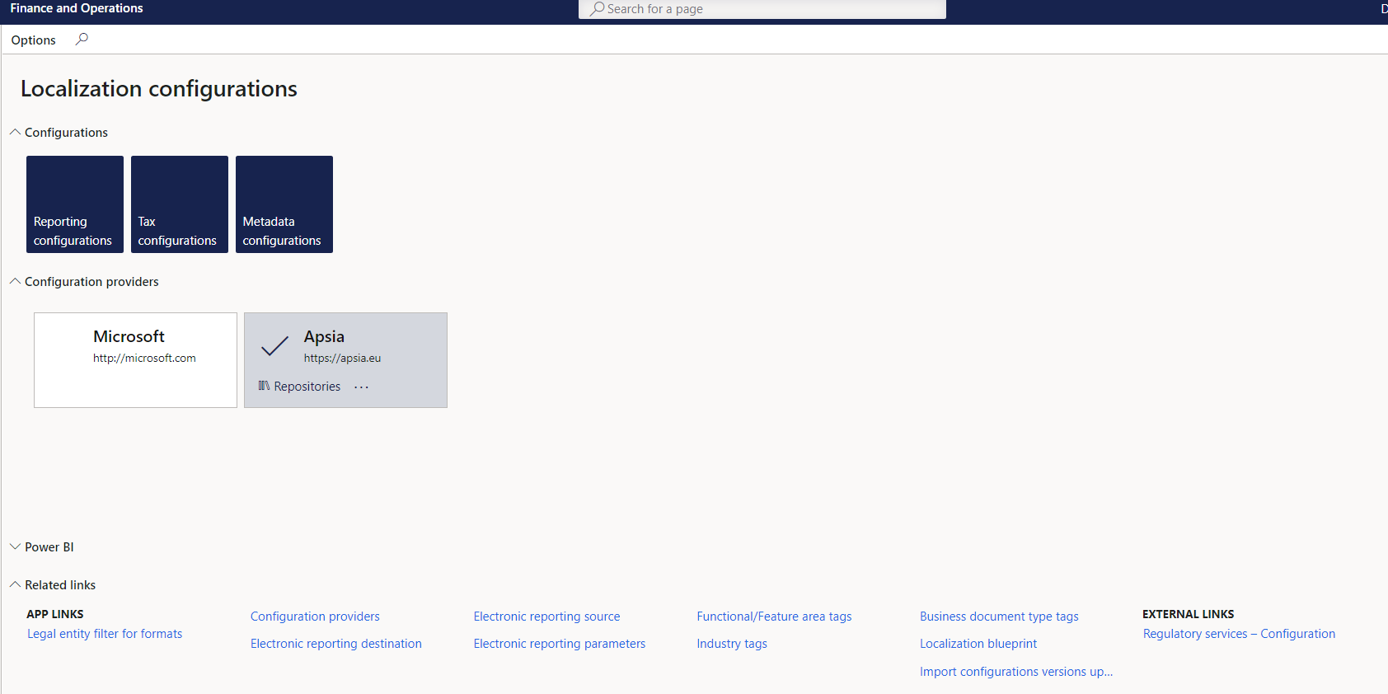

Creating new configuration

◆

Now open workspace in D365 F&O front end then workspace -> Electronic

Reporting

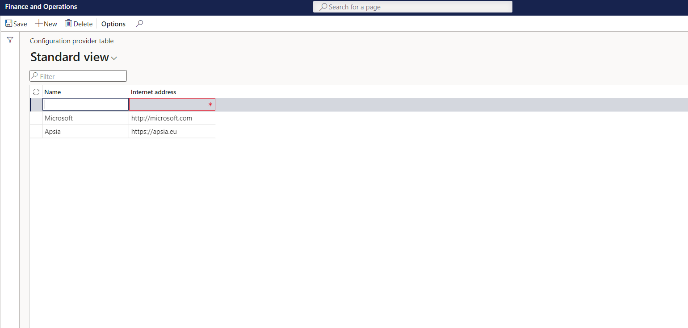

Add the name of new provider and the HTTP address.

◆

providers

Go to Workspace > Electronic reporting. And then click on Configuration

◆

**Now for creating new configuration providers**

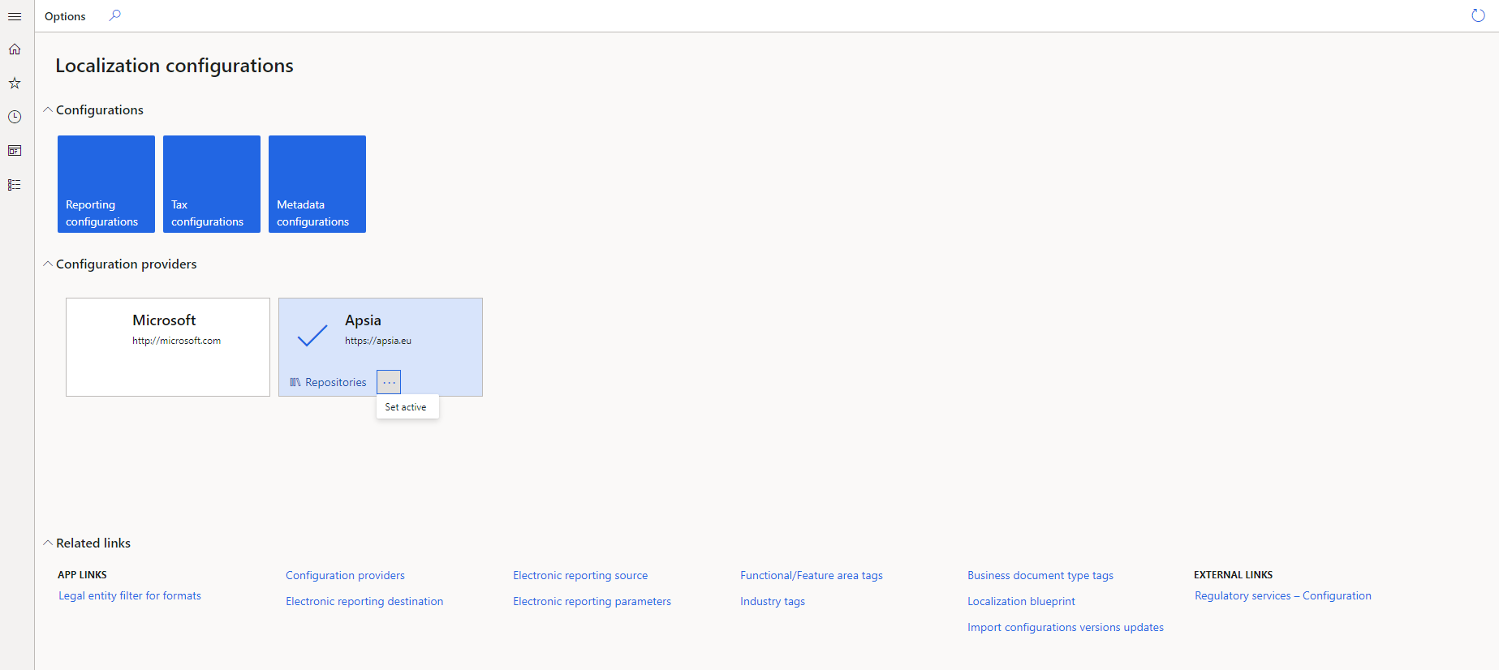

◆

Now save it and set your configuration provider set as active .

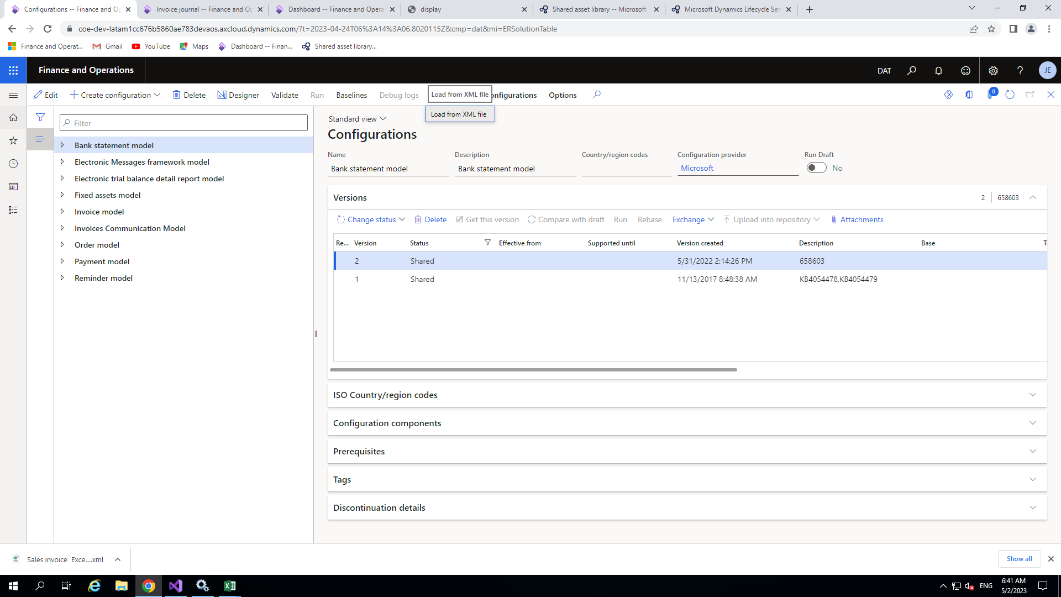

◆

Now click on configuration provider other than Microsoft and click on

reporting configuration then the following window will open.

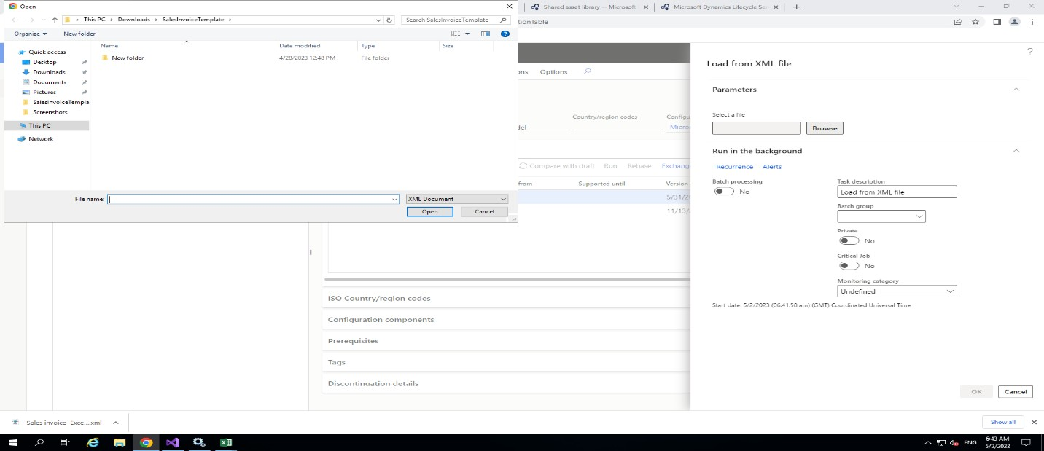

◆

Now click on exchange > load from XML and choose the downloaded xml

file which you downloaded from LCS go to your downloaded location and

open it one by one.

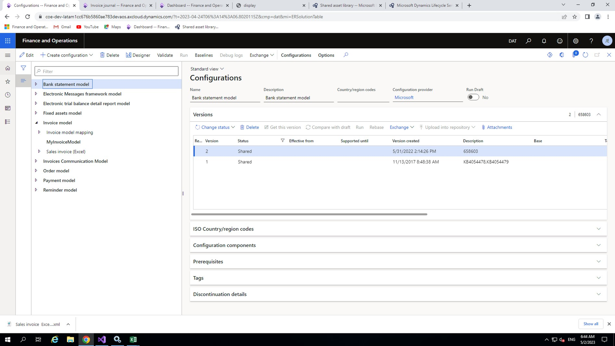

configuration button to add the extension of the model.

your configuration provider , so click on the model then click on the create

customization you need to create your own model for the configuration in

the window but it is recognized as Microsoft configuration .For the

After importing all the files, Your model, mapping and format will appear in

◆

Model configuration

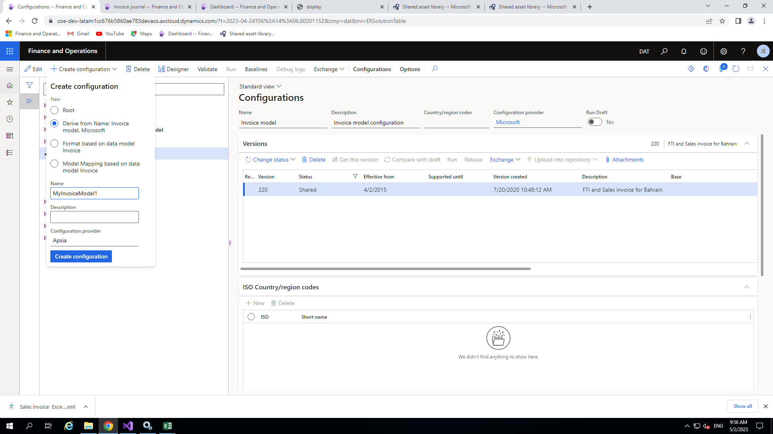

Simply you are extending existing one for the configuration.

◆

model Microsoft >

MyInvoiceModel) and check the radio button<Derive from name Invoice

click on create configuration .Give the appropriate name(like

So now we will create one extension for that, click on main model and then

◆

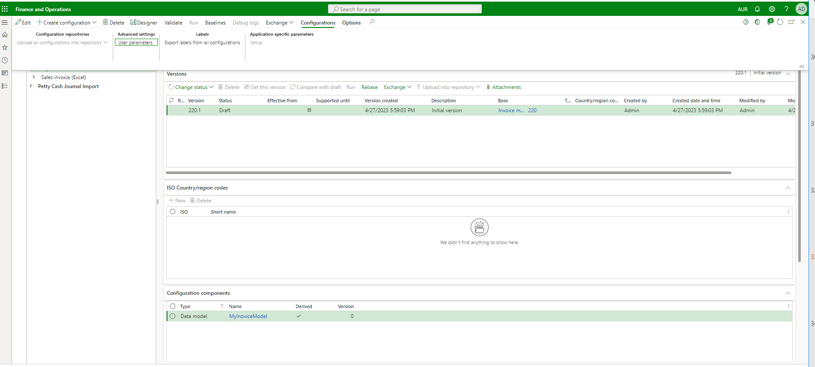

◆

After adding new data model configuration click on that model and then

configuration>User parameter

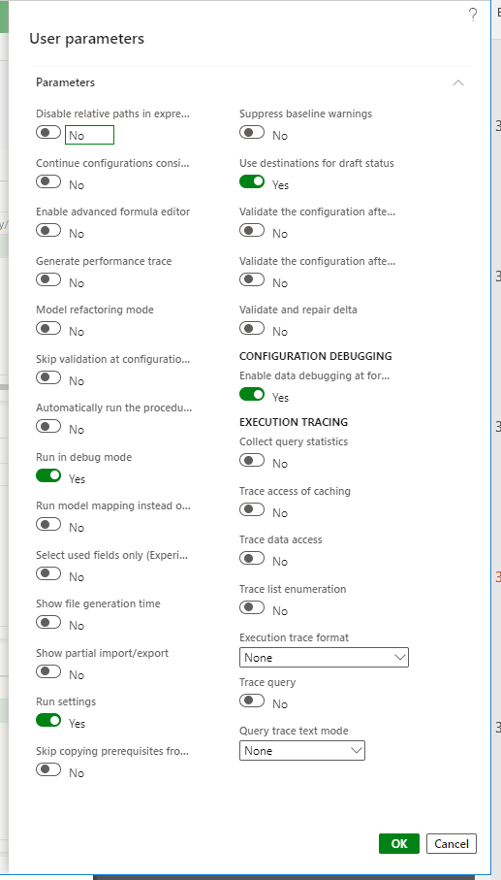

◆

Then turn on the parameter which is

showing in the picture then you can debug

your output in order to get the right output.

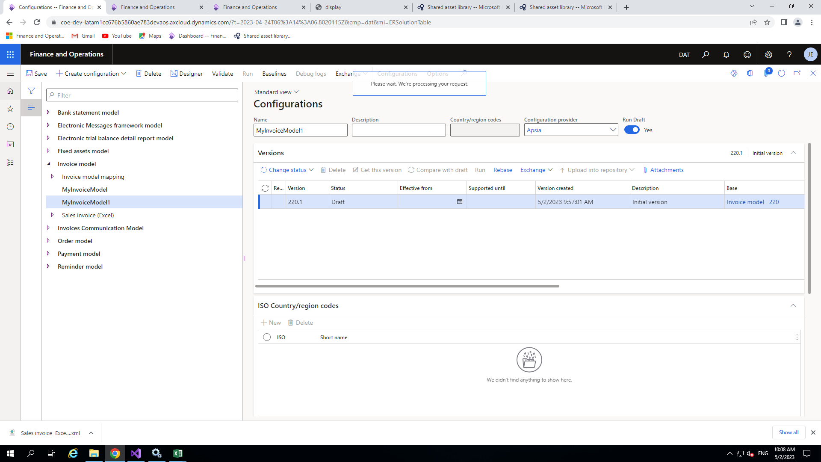

Adding new field in the data model

◆

After setting the parameter select the model and click on designer.

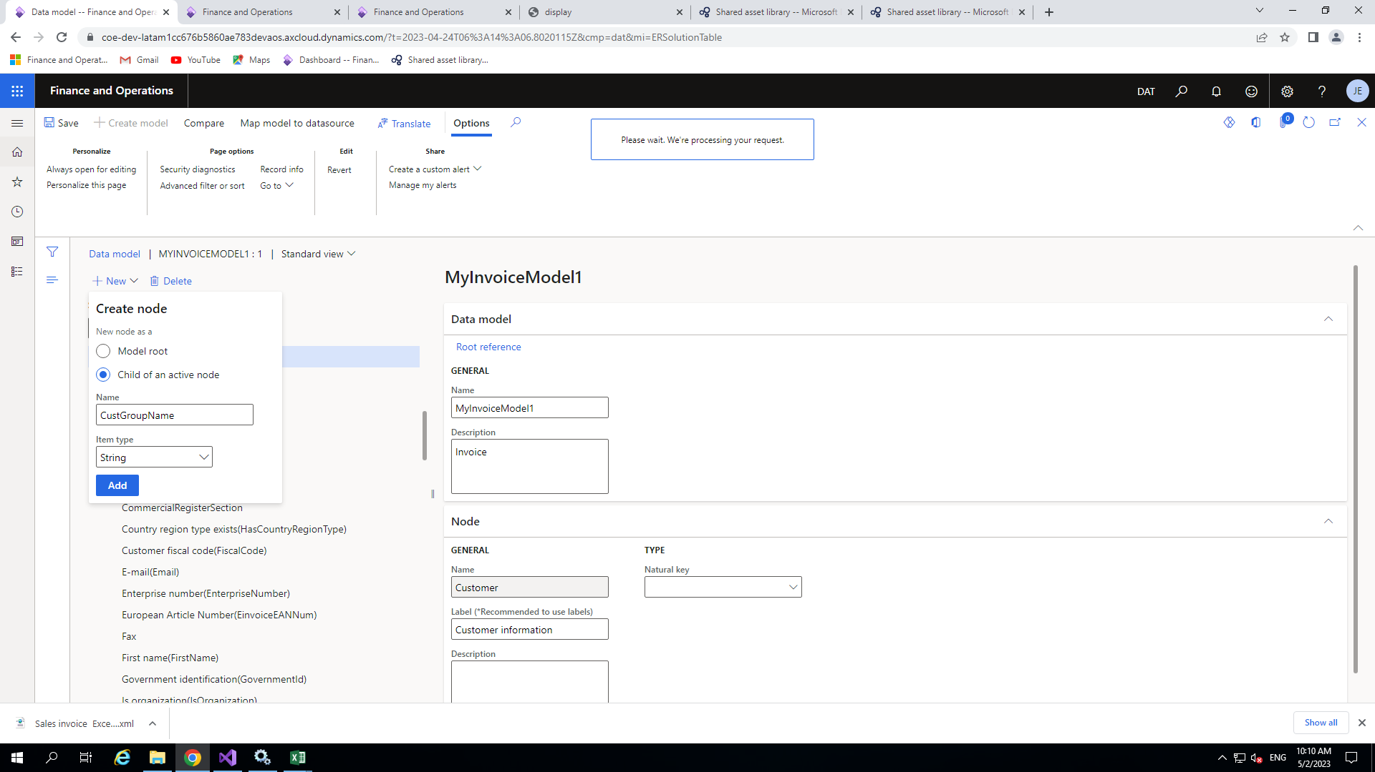

node

item type as string after that click on add. It will be add under customer information

button <Child of an active node> the give proper name(CustGroupName) choose

For adding select customer information node and click on new button check the radio

◆

type under Customer information node.

per my requirement I am going to add our CustGroupName field which will be string

Now our requirement is to add a field in the data model under appropriate node. As

◆

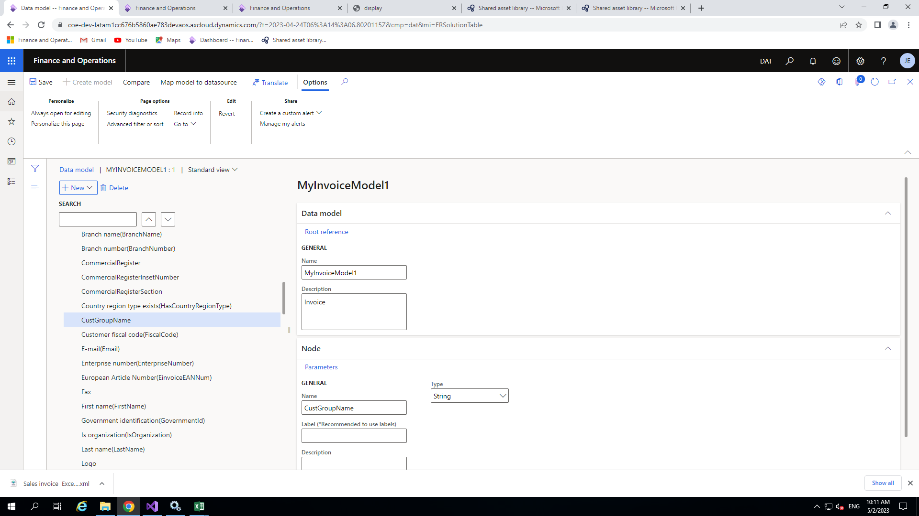

◆

After adding the node our node looks like this



Give the proper name like MyInvoiceModelMapping chooser your configuration

provider under target model then click on Create configuration.

◆

clicked on create configuration.

So choose your model mapping in my case I choose Invoice model mapping and

◆

customization in our configuration providers.

Like model configuration we will create the model mapping configuration for the

◆

Model mapping configuration

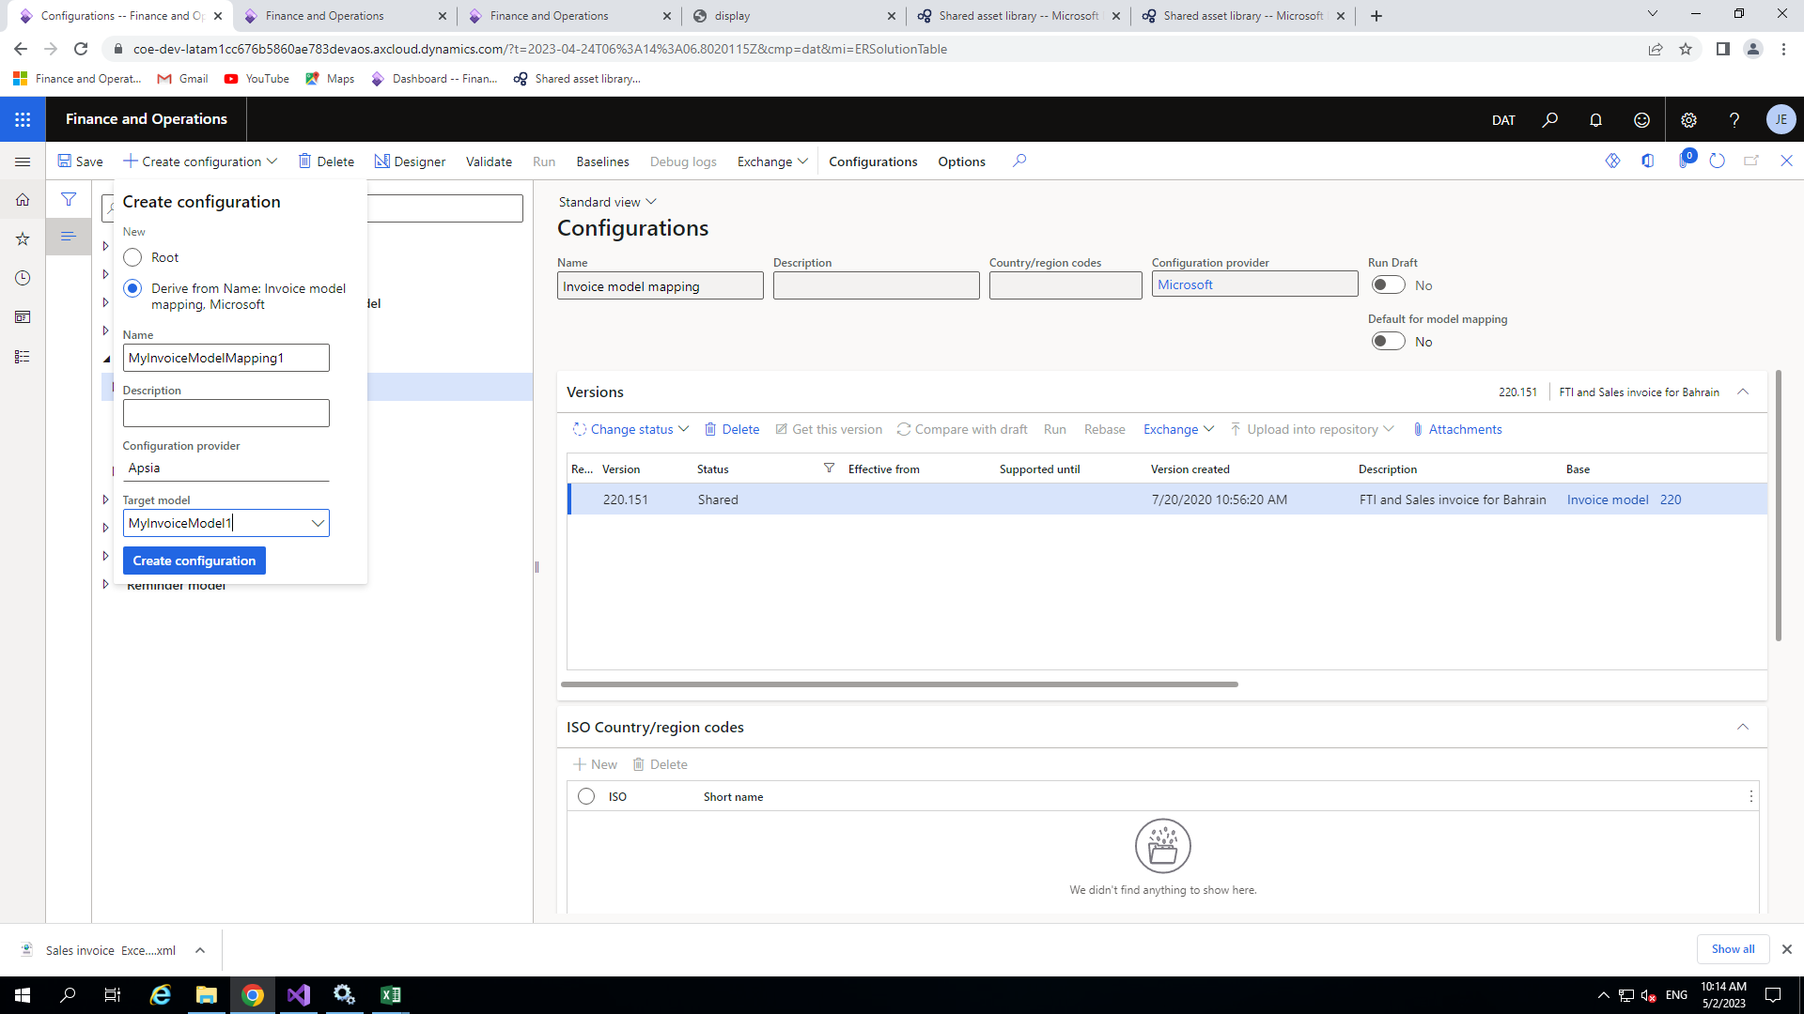

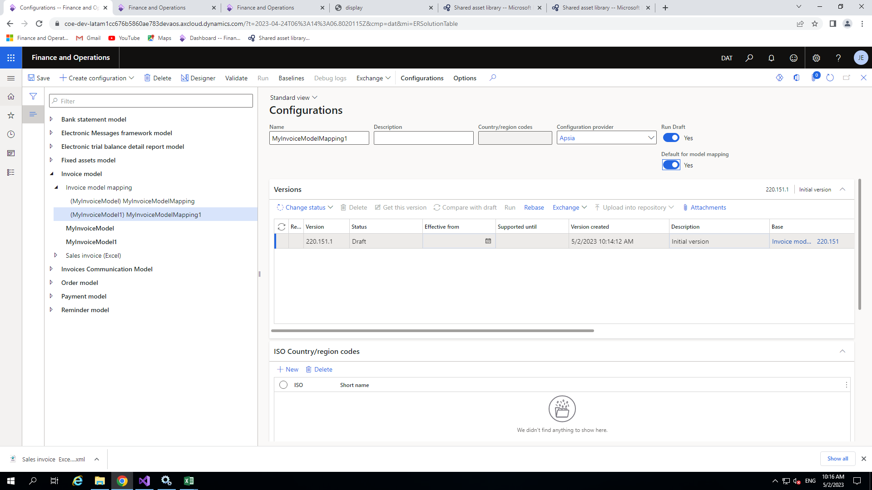

◆

Now your model mapping will be visible in the window.

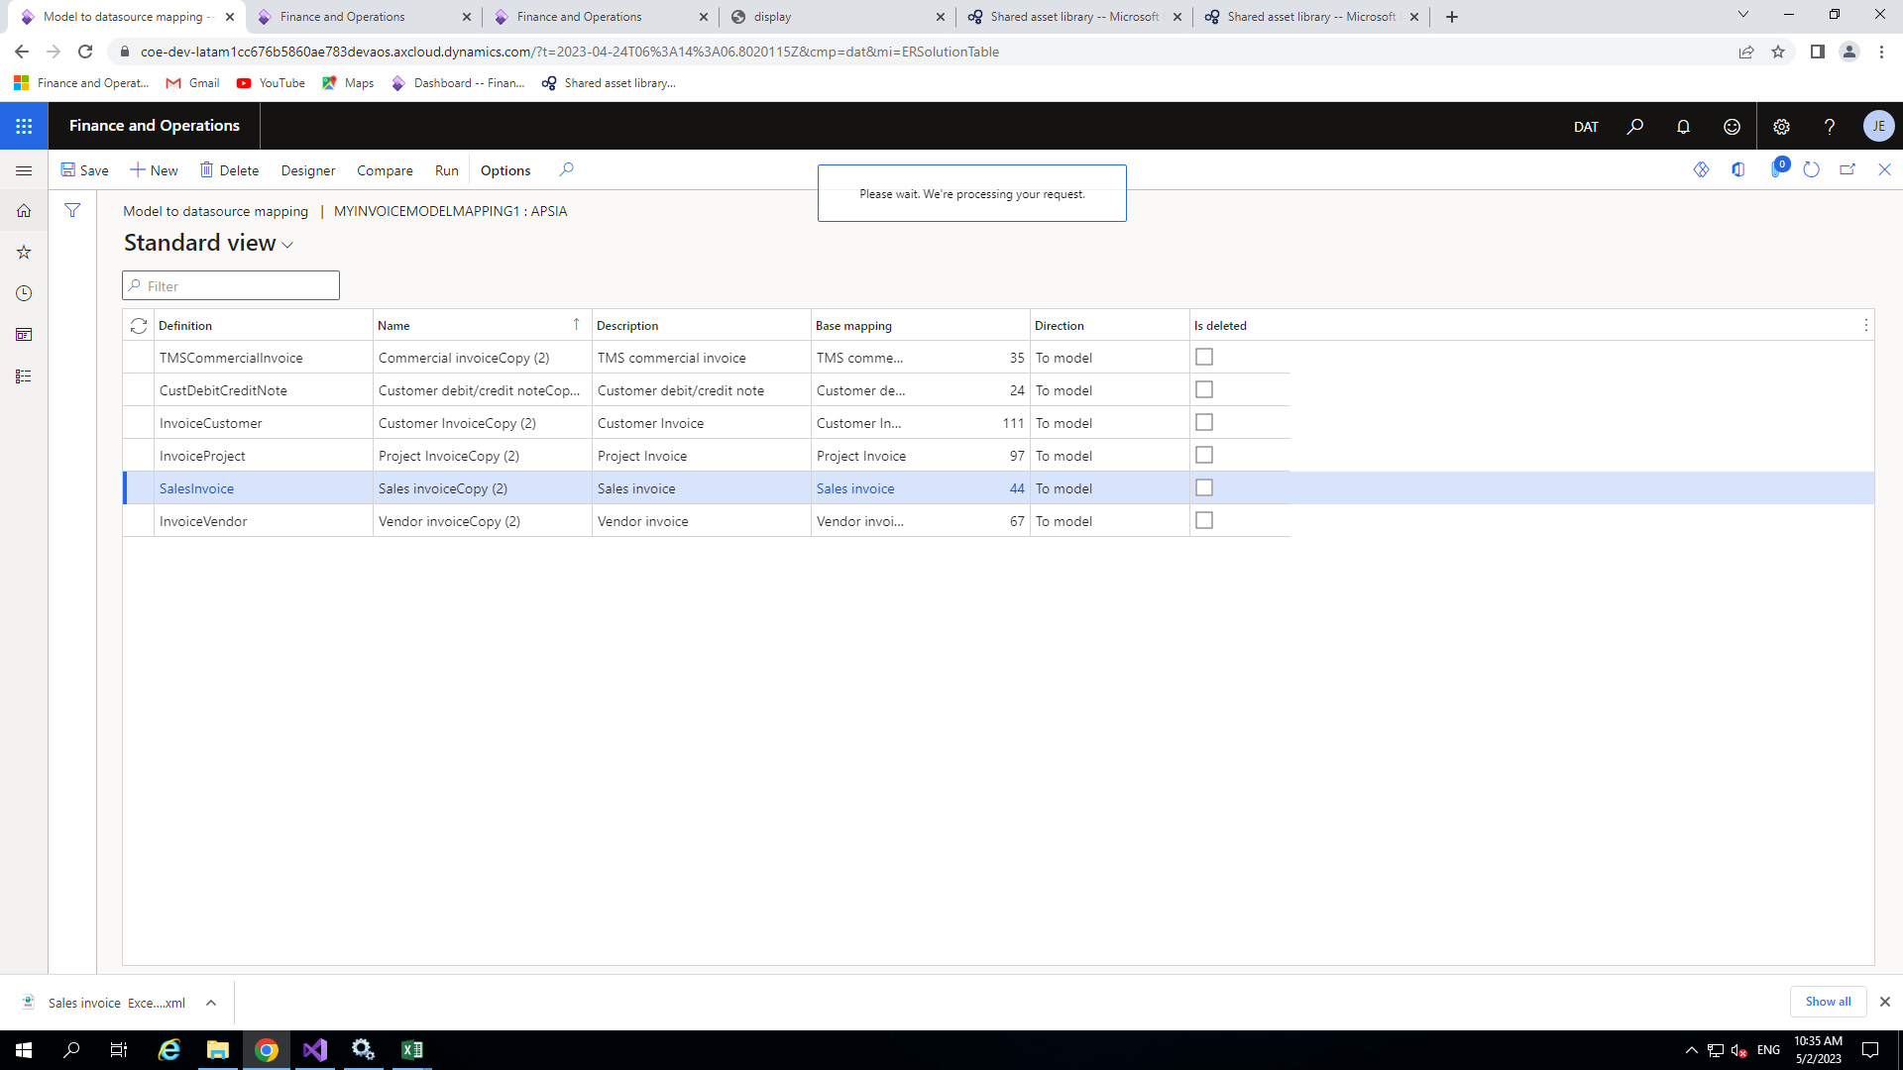

click on the designer again for the mapping.

here you need choose one like I will choose sales Invoice and later will

new window will open including one or more data source for mapping

Now choose your newly created model mapping and click on the designer

◆

Binding data field to data model



◆

You can see this process in the picture in the next slide.

◆

After that click on save.

Choose your field and click on Bind which is on the top on Data model area.

◆

Then go to Data Model area and find your field which you have been created previously.

◆

Jour)>Relation>Cust Group>Description(Name)

$SalesInvoiceTmp>Relations>Customer Invoice Journal(Cust Invoice

report here my field in belong to Customer Invoice Journal so for this I click on

Now you will have to find the data source of your field which you want to add in the

◆

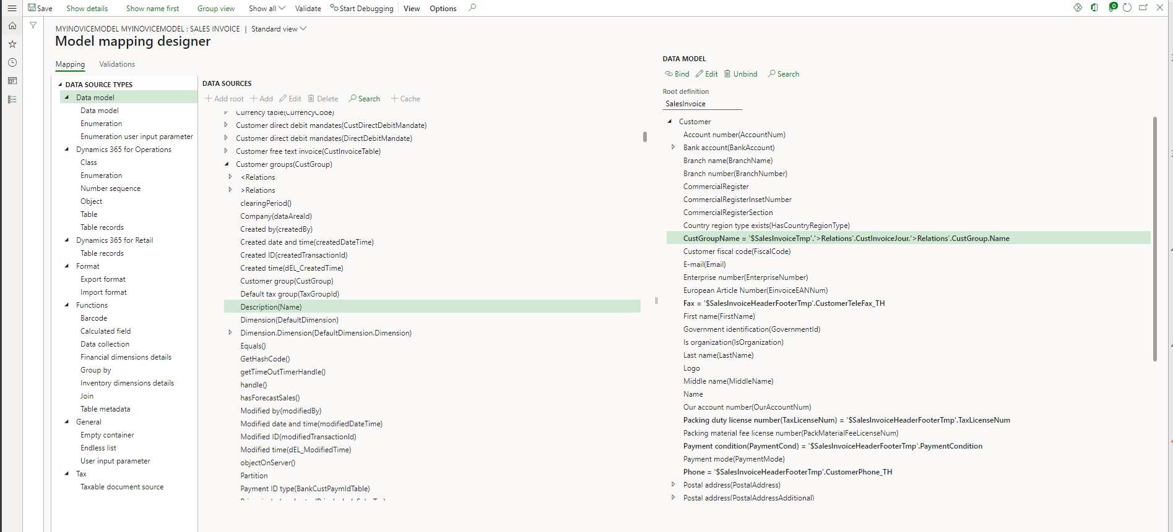

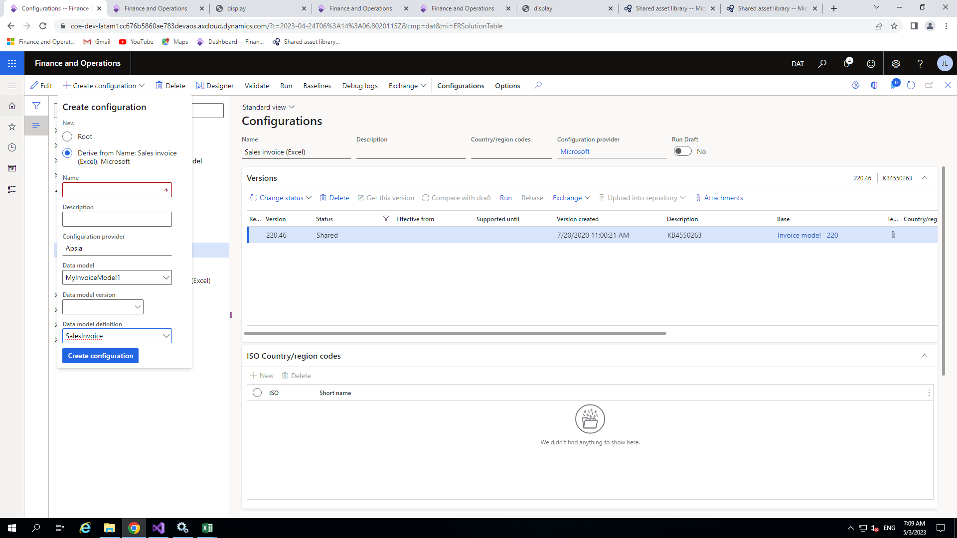

data model(MyInvoiceModelMapping).After that click on create configuration.

Give proper name(MySalesInvoice) then choose your configuration provider (Apsia)and

◆

configuration providers .

Choose your format and click on Create Configuration in to do the changes under your

◆

FORMATTING CONFIGURATION

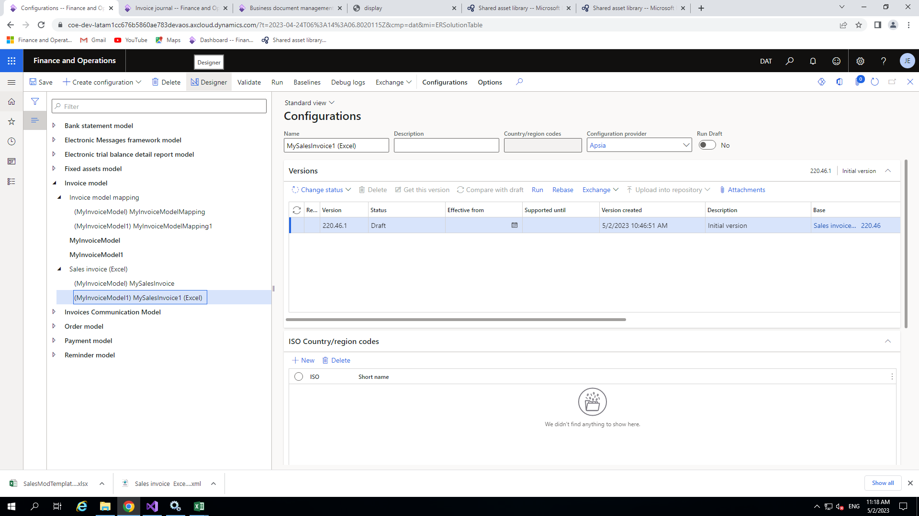

◆

Now your format (MySalesInvoice) will be add.



then click attachment .

Now Go to and choose standard SalesInvoice(Excel) or your My sales Invoice

◆

SalesInvoice(Excel)

the customer Invoice journal which is already available in the

Before moving ahead we need to download the report format in excel for

◆

Customization template

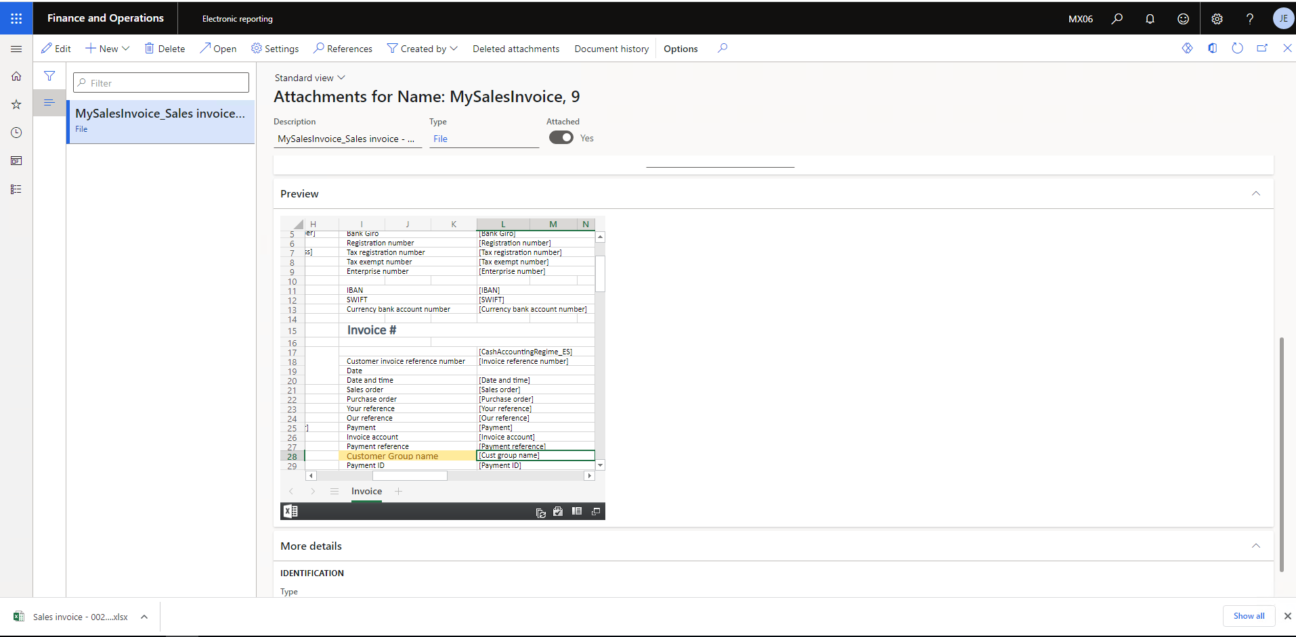

Once It downloaded you need to add your field like customer Group Name

into your template and save it

◆

It will download in your system

◆

Now choose this and click on open button

◆

format which will come when we will print customer Invoice Journal form data

New window will open now go to Preview Tab and you can see here the report

◆

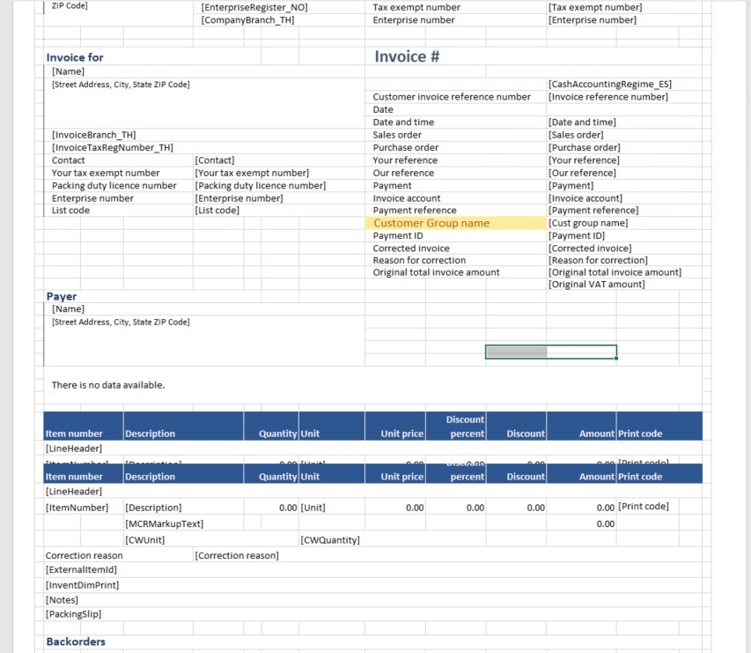

◆

You can add your required field in the template shown in the picture and you

can add field like Cust Group Name.

◆

Then save it for importing purpose.



In Action pane tab you will see import button.

◆

designer

Now choose your newly created format (MySalesInvoice) and click on

◆

Importing the template

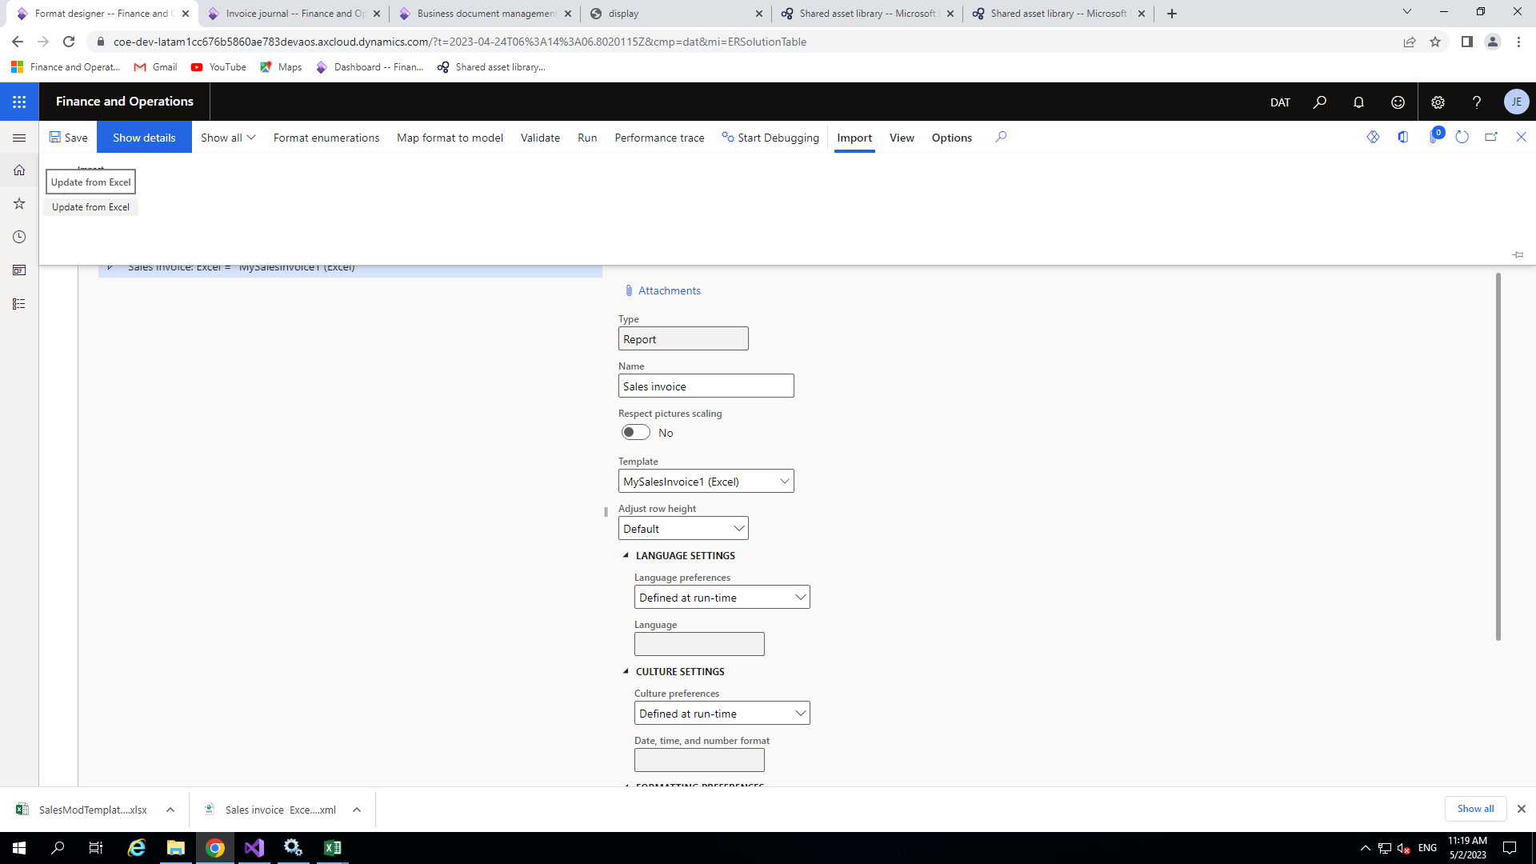

◆

The next step is to import new template so just simply click on import and

update from Excel

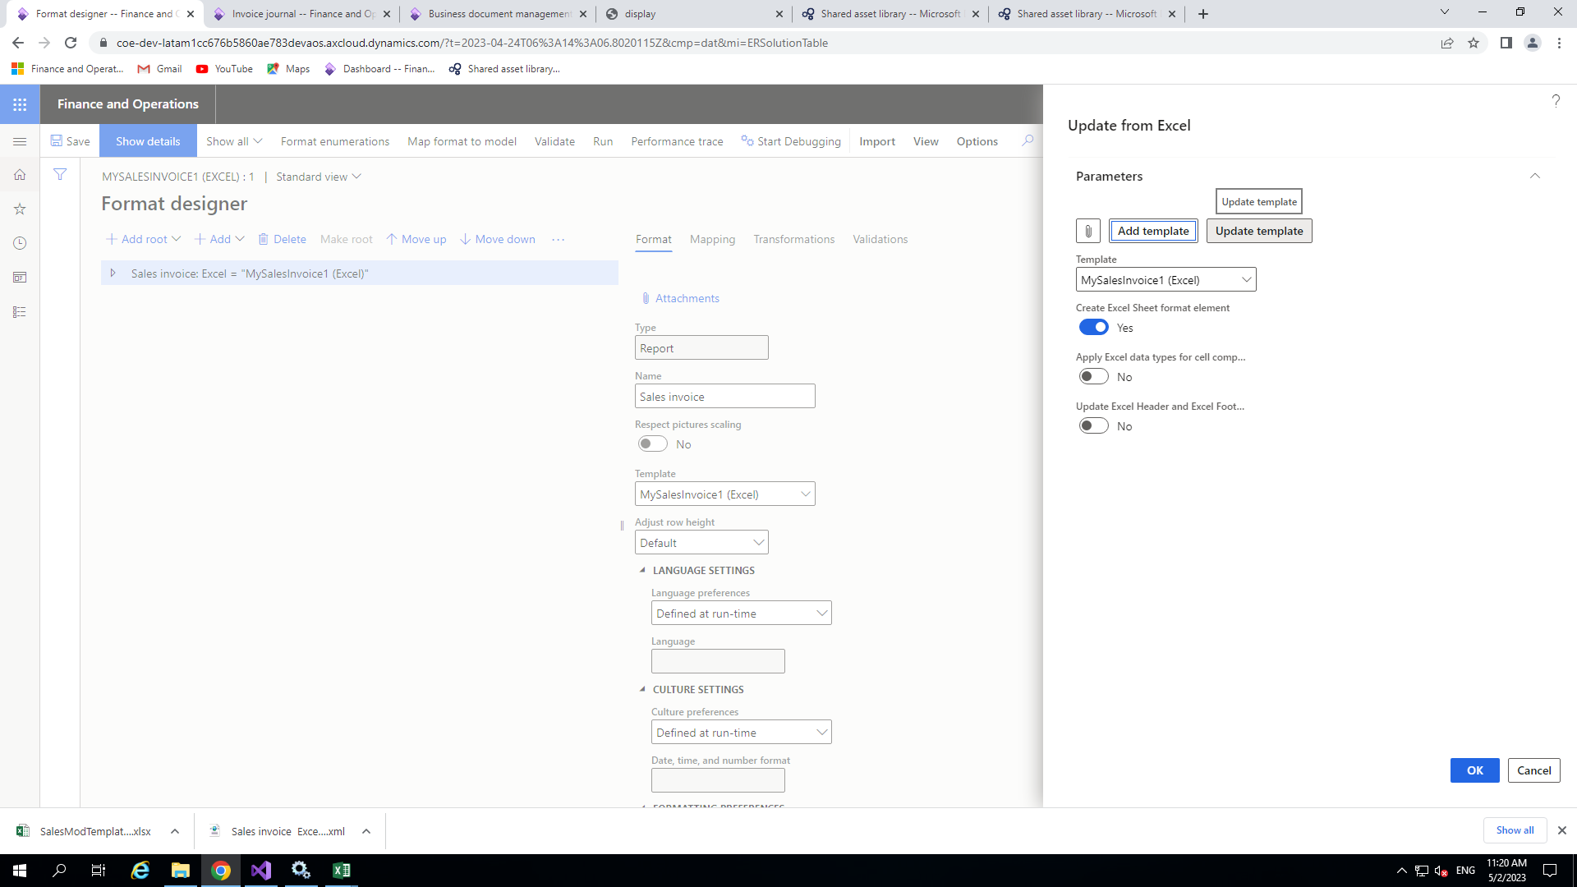

◆

In ‘Update from Excel’ click on Update template and choose your

customized template.

◆

<create Excel sheet format element> keep it turn on and then click ok.

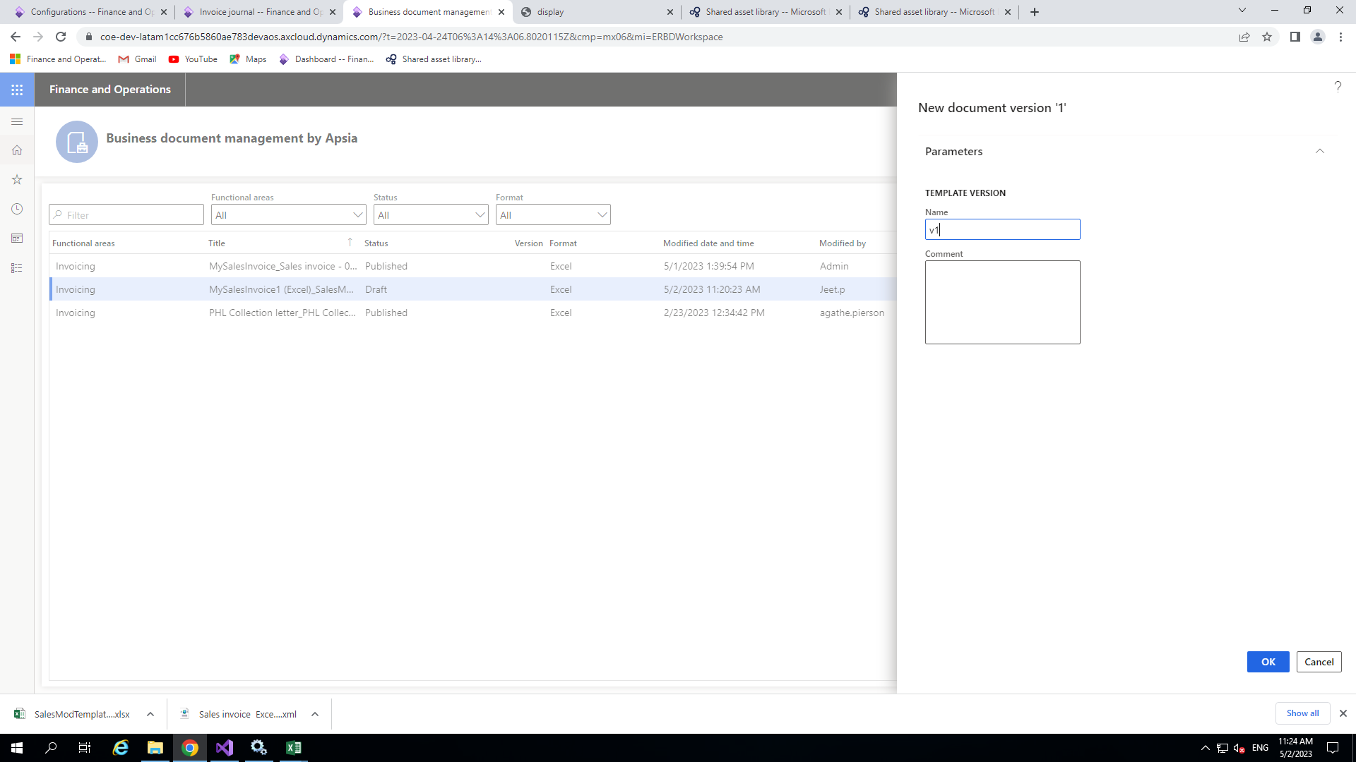

**Ok .**

After that one dialog box is open just enter the version number and click

◆

below preview of the excel

the invoice which you imported and just click on edit button at right side

Now open **business document management** from front end and select

◆

Business Document Management

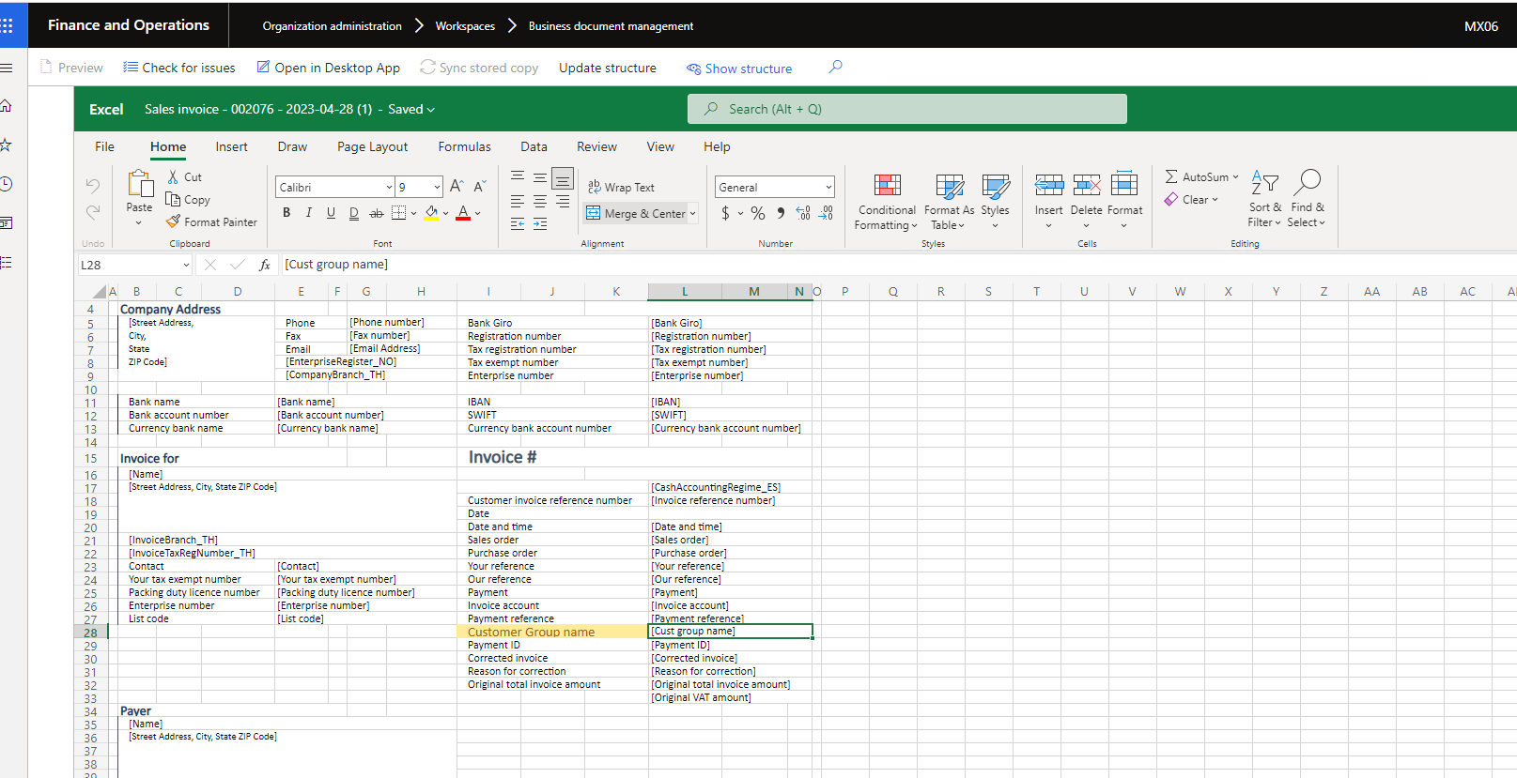

◆

Once the excel file is open click on show structure .



Now click on Add >cell then give proper name like I gave the name as ‘Document

And then click on ok button.

◆

Details_CustGroupName_Value’

◆

selected.

I selected this range and my excel template field which I want to mapped already

◆

In my case I will add the field under Range<DocumentsDetails>Vertical.

◆

excel in xml format .Now identify the range where you want to add the field.

Then Template structure dialog box will open .Here You can see the structure of your

◆

Templet description

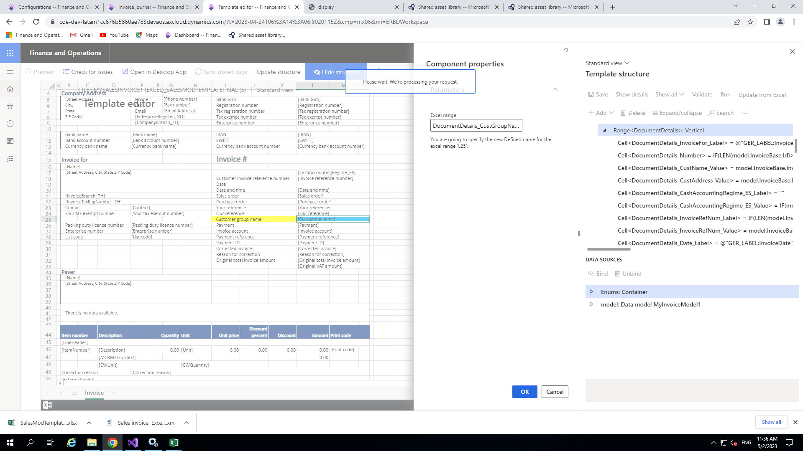



◆

Now it has been bind Now save it .

◆

After selecting my field I clicked on the Bind button.

In my case model>customer>Cust Group Name

◆

try to find out the field which you already added in the data model.

A new window pane of data source will appear this window. Now choose your model and

◆

click on this .

available in this window if you are not able to see this click on there dot it will seen and

Now I need to bind the field with the data source for this click on show binding option

◆

Binding field with the data source

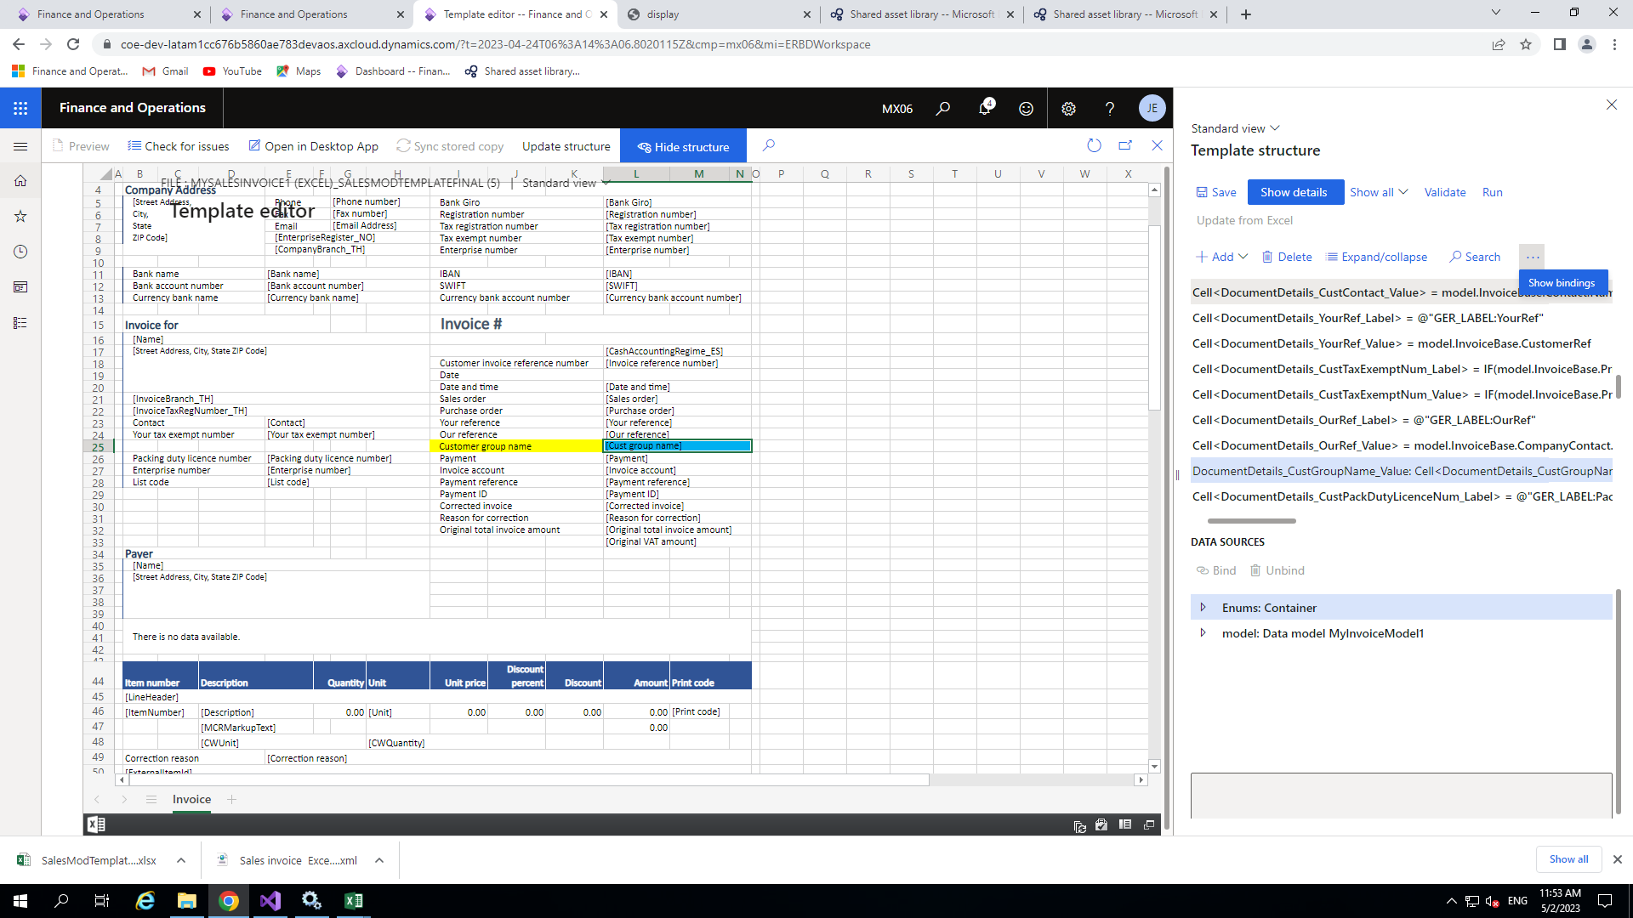

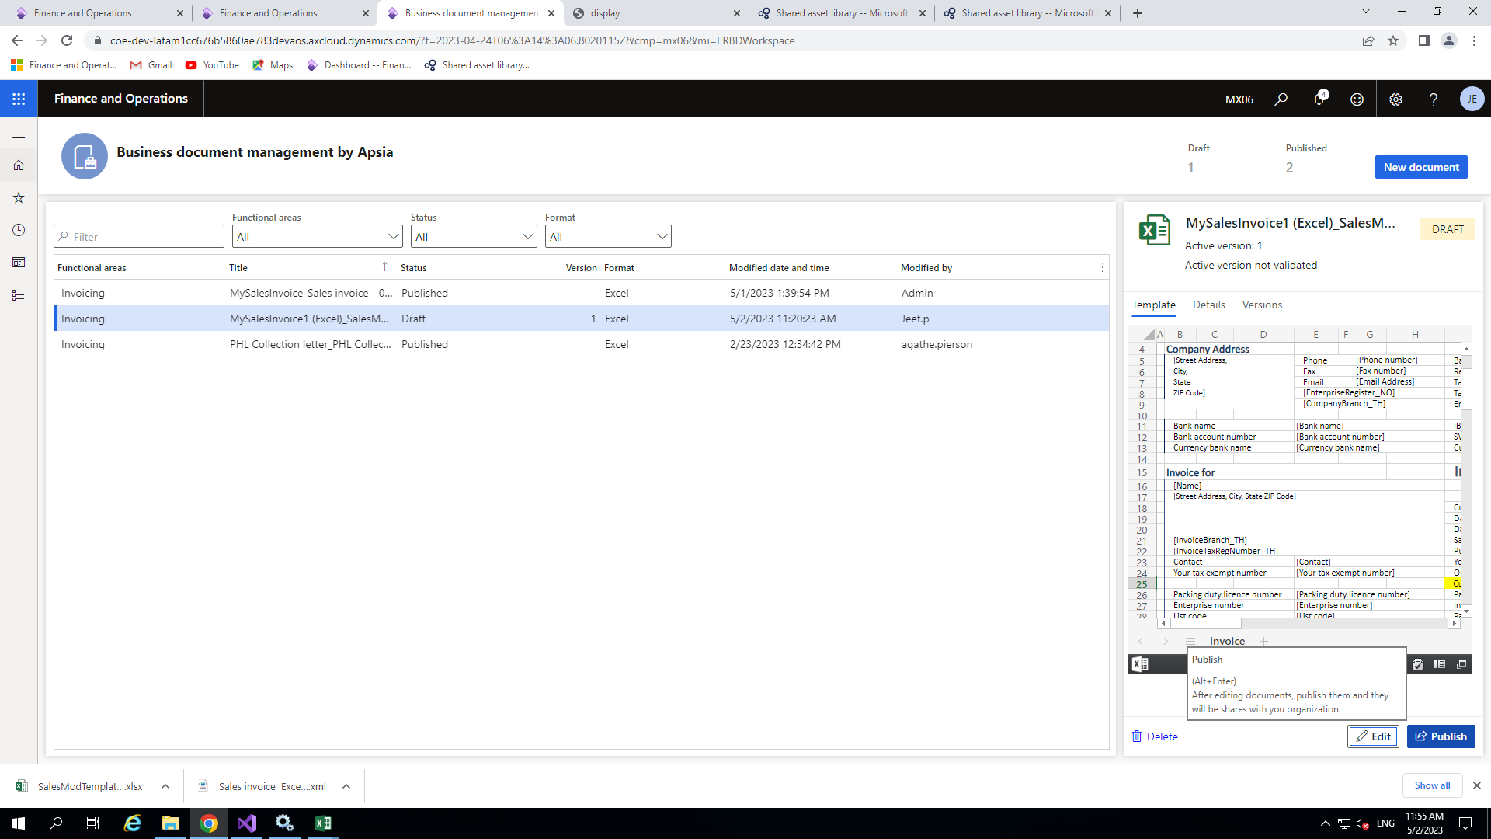

Now your template has been published for the reporting.

◆

publish button which is near to Edit button.

So close binding window and Excel template window and Now click on

◆

template .

After binding the field you need to publish you newly added Excel

◆

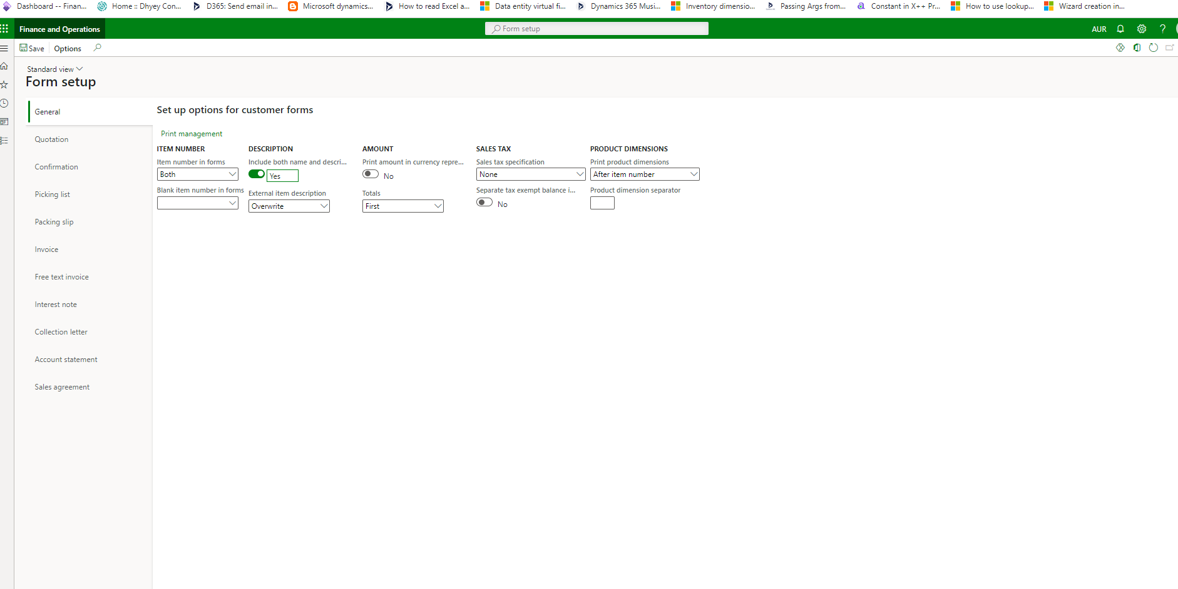

Set the parameter of the form as in the following picture.

◆

Go to Account receivable>setup>forms or you can directly search.

◆

Next step you need set some parameter in form setup form

◆

Form Setup



◆

You can also change the destination like I set it as Screen.

◆

choosing here My Sales Invoice.

Now under the setting go to Report format and here choose your format like I am

on the new.

Click on Original<Default> if it already available it’s ok other wise we can add clicking

◆

For this Go to >Customer Invoice

◆

Here we need to set our newly published Report Format.

◆

Now click on Print management option which is on the same screen .

◆

Print management

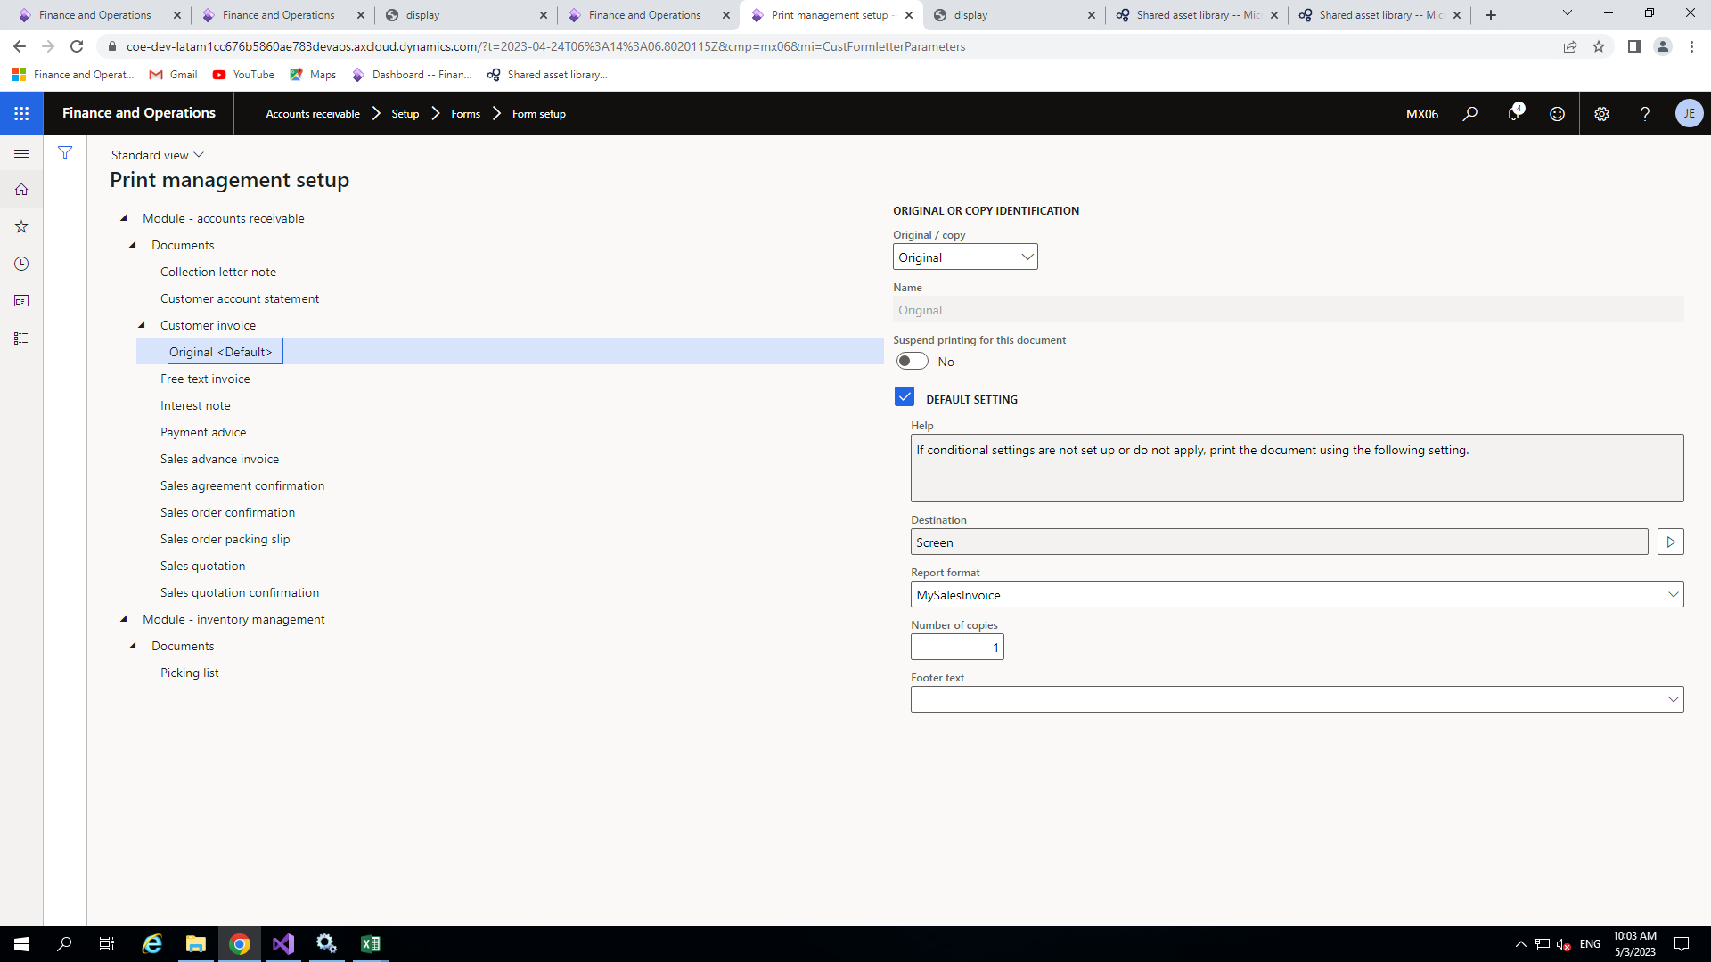



click no.

Your report will download in excel format.

◆

Here it will ask for debugging if you set you model user parameter for debugging other

◆

management.

Now go to cust Invoice Journal form and select any record and click on View>use print

◆

Now we are all set to see our output.

◆

Printing final output

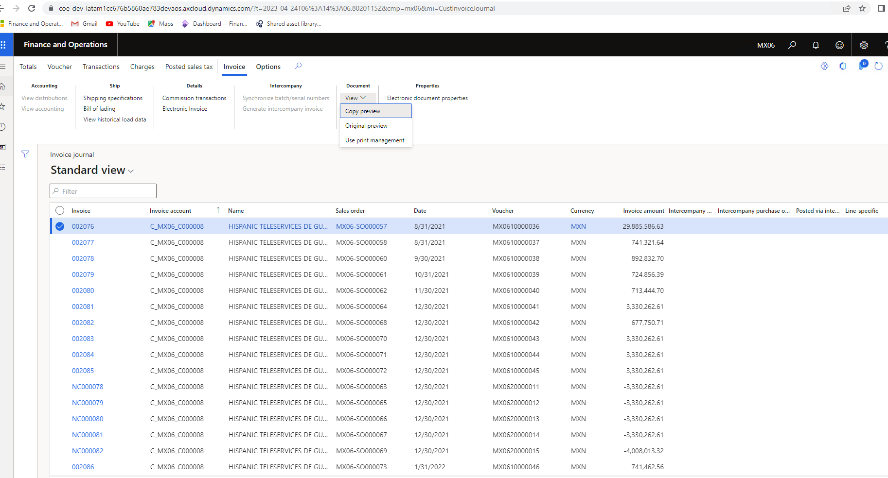

In d365

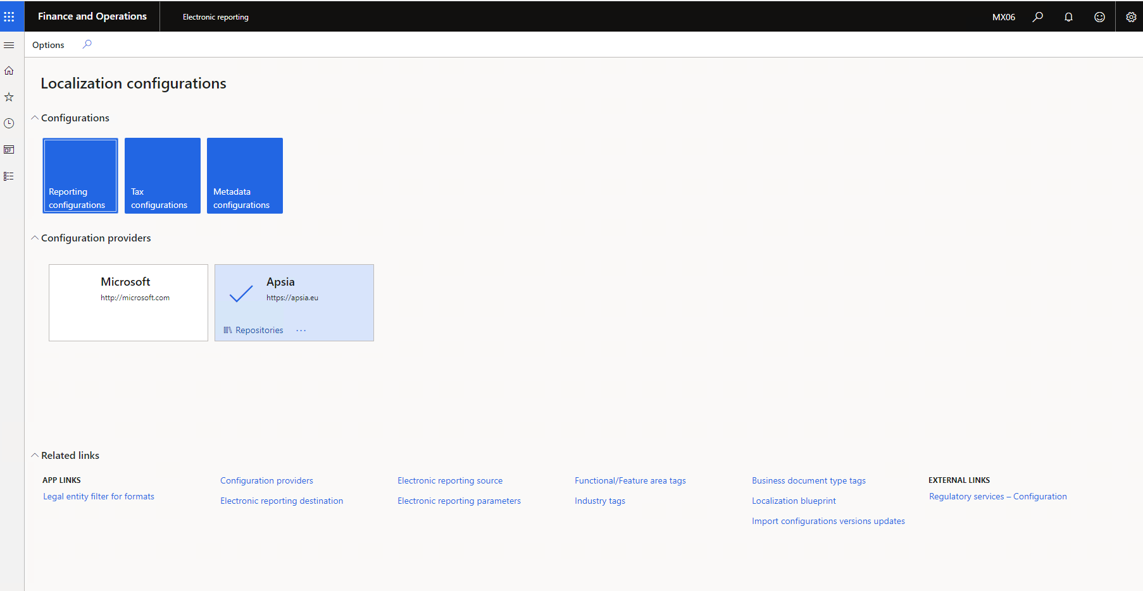

Electronic reporting destination

◆

Go to workspace>Electronic Reporting

◆

After that click on Electronic reporting destination

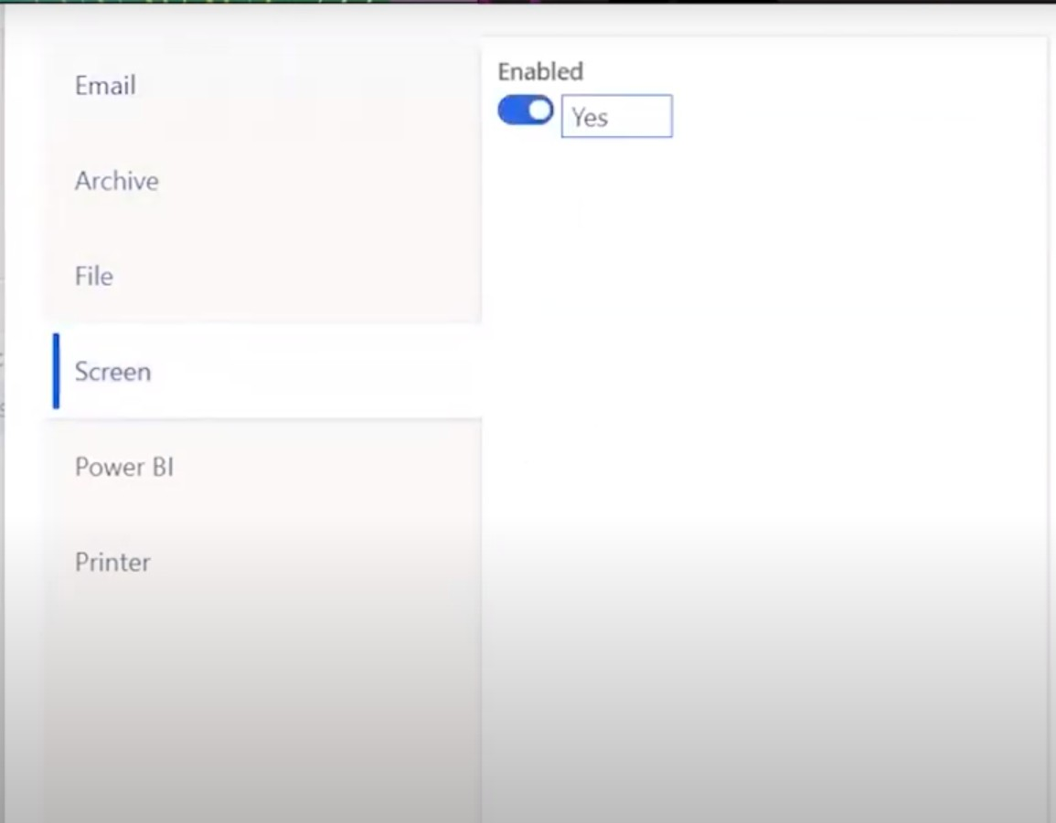

Then check the convert to pdf

pdf format.

set now to print our report in

Now save all setting we are all

◆

format.

so output will come in pdf

◆

according shown in picture.

up window will open and set it

After that click on setting pop

◆

choose Sales Invoice.

Choose file component name I

◆

lilke I set Screen(pdf) as name .

click on New button then Name

to set the file destination so

Chosse your format and need

◆

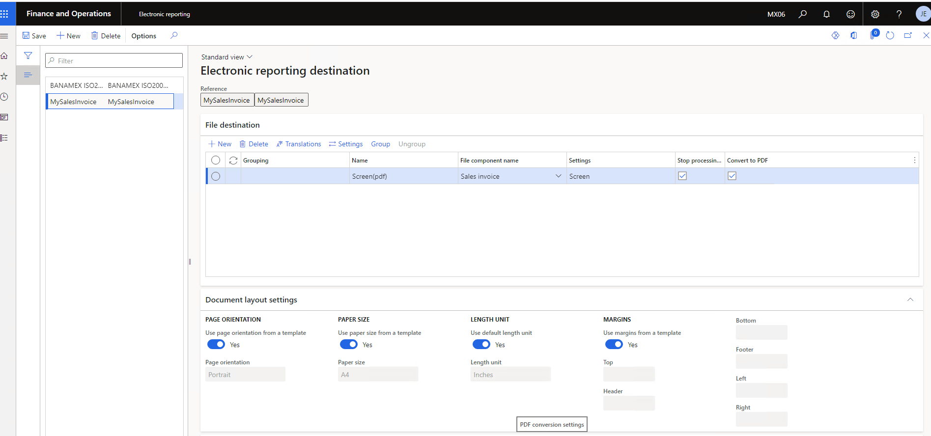

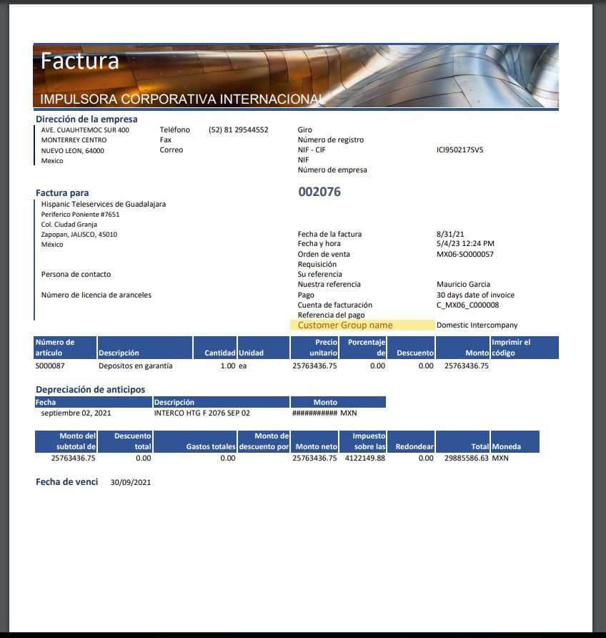

◆

Customer Group name.

Here you can see the

following.

Now you report will print as

◆

click on Original preview.

Management or you can

view>Use print

Journal form click on

Now go to Customer Invoice

◆

Final Output In pdf format



Thank

you.